Title

Laura Fernández Arroyo1 & Nuria Sagarra1

1 Rutgers University

Author note

Correspondence concerning this article should be addressed to Laura Fernández Arroyo, Rutgers University - Department of Spanish and Portuguese, 15 Seminary Place, New Brunswick, NJ 08904, USA . E-mail: [laura.fdeza@rutgers.edu](mailto:laura.fdeza@rutgers.edu)

Abstract

Title

# 1. Introduction

Multiple studies have shown that listeners make predictions during speech (e.g., Altmann & Kamide, 1999; Sagarra & Casillas, 2018). Traditionally, linguistic prediction has been researched on its own, not heeding its possible association with the larger cognitive skill repertoire a person has. Recently, some scholars have highlighted the need to consider the broader cognitive context in which linguistic prediction takes place (Ellis, 2019; Ryskin, Levy, & Fedorenko, 2020). Two different approaches explain how the acquisition and use of predictive mechanisms may function in this broader cognitive context. First, as an independent mechanism unlikely to relate to mechanisms in other cognitive domains. Second, as a skill whose mechanisms may be transferred to and from other domains. The first view is compatible with domain-specific cognitive models. The second one with domain-general cognitive models.

The goal of this paper is two-fold: 1) to study transfer of anticipatory skills from the visuospatial domain to speech to process associations of lexical stress-verb tense suffix for speech in an L1 and an L2, and 2) to study the mediation of cognitive abilities (i.e., verbal and visuospatial processing speed in language prediction) and linguistic characteristics (L2 proficiency and stress patterns) in that transfer. We chose a phonomorphological association to test language prediction to make sure that linguistic prediction not only took place in an auditory modality, thus differing from the modality of the other domain tested–visual, but also that it relied on auditory information as a cue, therefore requiring a deep processing of the linguistic information. The relationship between speech and the visuospatial domain will provide insight into transfer of domain-specific predictive skills. The inclusion of processing speed seeks to explore the effect of domain-general mechanisms that have been less researched so far on domain-specific predictive skills. Finally, the inclusion of L2 speakers at different levels proficiency aims to explore how skill acquisition and transfer evolves over mastery of an L2. Thus, this paper will inform models of cognition and learning about how processing mechanisms can be shared by cognitive domains in different modalities (visual vs. auditory).

# 2. Background

## 2.1. Language prediction

According to the predictive brain hypothesis (Clark, 2013; Helmholtz, 1962; Rosen, 2012), prediction is essential for processing information because it alleviates the cognitive load and makes up for loss or lack of information due to noise or ambiguity. During prediction, the brain combines perceptual information with previous acquired knowledge about the world to infer what is going to happen (Clark, 2013). This inference is used to predict both what we are going to see (e.g., in driving: Morando, Victor, & Dozza, 2016; in sports: Nakamoto & Mori, 2012) and what we are going to hear (e.g., in music: Di Liberto et al., 2020; in language: Altmann & Kamide, 1999). In language, prediction has been extensively researched, showing that speakers are able to generate predictions in their L1 (e.g., Altmann & Kamide, 1999; Grüter, Takeda, Rohde, & Schafer, 2016) and in their L2 (Dussias, Kroff, Tamargo, & Gerfen, 2013; Sagarra & Casillas, 2018) to a lesser extent. A factor considered in previous research determining ability to predict has been verbal working memory (vWM). The consideration of this factor is a first step to elucidating whether linguistic prediction is underpinned by language domain-specific mechanisms or, contrastingly, whether it may be influenced by other non-linguistic mechanisms.

Research on prediction in language has traditionally been confined to language itself, with little research on if and how it connects to other cognitive domains, general or specific. Exceptionally, a handful of studies have explored the connection between linguistic prediction and vWM, revealing mixed findings. Otten and Van Berkum (2009) explored the influence of WM on Dutch speakers’ ability to predict nouns based on congruent or incongruent determiners. ERP data revealed that vWM did not affect participants’ ability to anticipate words, but it influenced how incongruent information was processed. Huettig and Janse (2016) further explored the role of vWM and verbal processing speed (vPS) in Dutch speakers’ anticipation of nouns based on the gender of those nouns. Eye-tracking data showed that enhanced vWM and vPS positively affected anticipation. Given that the major difference between both studies was the method of data collection, one could argue that WM may have more behavioral effects rather than cognitive ones. However, a posterior eye-tracking study on anticipation of verb suffixes in Spanish based on lexical stress revealed no vWM effects for either monolingual or late L2 Spanish speakers (Sagarra & Casillas, 2018). Lastly, Lozano-Argüelles, Sagarra and Casillas (under review) conducted a study with a similar setup to Sagarra and Casillas (2018)’s that also included interpreters, who are used to predicting due to their work requirements, making their processing cost lower. They found that vWM facilitated prediction in monolinguals and interpreters when the cognitive load was heavy, but when the cognitive load was light, vWM facilitated prediction in non-interpreters.

The inconsistent findings on vWM across studies suggest that domain-general capacities may mediate anticipation rather than determine it. Following this hypothesis, language prediction abilities may be mostly specific to the language domain, but they may rely on other abilities that are general to cognition at large in certain situations. Given the differing results obtained for different populations regarding linguistic prediction, it is possible that the situations in which domain-general or other cognitive capacities affect linguistic prediction vary across populations depending on factors such as the language they are speaking (i.e., L1 vs. L2) or their proficiency in the language.

The idea that language prediction may be at least partially underlied by non-linguistic cognitive abilities is compatible with cognition models that prioritize domain-general learning mechanisms, positing that different brain domains are connected to each other, such that the acquisition of a skill in one of them may influence learning of unrelated skills. This influence, or transfer, takes place because and to the extent that the skills depend on domains that share common features (Thorndike, 1901) and cognitive elements (Anderson, 1990), in the form of perceptual and conceptual information (Singley & Anderson, 1989). In the case of vWM, it being a domain-general skill, the ability may adapt to specific domains according to the individual’s needs.

In contrast to domain-general models, domain-specific learning mechanisms models argue that brain domains are independent and unrelated to each other. In these models, the more developed a skill is, the more domain-specific the features will be, reducing the likelihood of skill transfer from one domain to another (Ericsson & Charness, 1994; Gobet, 2015). Consequently, improvement of skills in a brain domain will have little to no influence in other domains. Following these models, skill transfer from other specific domains is unlikely. However, previous research has shown that music and language share some prediction mechanisms (e.g., syntax: Jentschke & Koelsch, 2009; rhythm: Magne, Jordan, & Gordon, 2016).

In sum, the current literature on language prediction does not allow to understand its underlying cognitive mechanisms. In terms of domain-general abilities, all studies have focused on vWM with only one including vPS. Additionally, studies comparing directly domain-specific prediction abilities are scant, and they have focused on auditory domains. Here, we contrast language prediction in speech against a radically different domain: visuospatial anticipation.

## 2.2. Language and visuospatial processing

We understand visuospatial abilities as the ability to process, work with and remember information in space perceived visually. Humans can predict visuospatial events in general situations (e.g., Bennett & Barnes, 2005) as well as specific (e.g., driving: Morando, Victor, & Dozza, 2016), and improve over practice (Nakamoto & Mori, 2012), just like speakers learning an L2 (e.g., Fernandez Arroyo, Sagarra & Lozano-Argüelles, under review). Visuospatial abilities are important for language in a myriad of ways, such as in space representation and in spatial concepts processing during reading. Visuospatial abilities are also important at the domain-general level.

In terms of space presentation, language interacts with the visuospatial domain to create and update our representation of space and the way we refer to it. Languages encode space in egocentric or in geocentric terms (Levinson, 1997), affecting our spatial reasoning (Levinson, Kita, Haun, & Rasch, 2002). In other words, depending on whether a language allows a speaker to create phrases like “to the left of the tree” or “north of the tree,” a speaker will conceptualize space differently. For instance, an egocentric encoding has resulted in linguistic and non-linguistic spatial representations relying on a common axis-structure in English (Crawford, Regier, & Huttenlocher, 2000; Huttenlocher, Hedges, & Duncan, 1991). Speakers use these representations to gauge space and distance in relation to themselves, other speakers and other referents to use spatial deixis and to make other spatial references. In this game, bilingualism also affects categorical perception of space; bilingual speakers’ space categories more flexible across languages than monolingual speakers’ space categories are (Holmes, Moty, & Regier, 2017).

Studies on reading abilities and spatial concept processing suggest that the linguistic and visuospatial domains may be closely interconnected in information processing. In typical populations, reading studies in children demonstrate that visuospatial skills are a reliable indicator of reading abilities in the L1 at the initial stages of reading development (Helland & Morken, 2016), and reading skills are a predictor of visuospatial abilities in the next literacy level (Lin, Sun, & Zhang, 2016). Studies on reading in adults indicate that visuospatial interference in language is larger in deep languages, that is, languages where a letter or string of letters may correspond to more than one sound, like in English, than it is in shallow languages, like Italian or Spanish (Estes & Barsalou, 2018)

Atypical populations have also provided evidence of an association between visuospatial and linguistic abilities in visuospatial processing. The populations that have been researched in this regard are individuals with Williams Syndrome, with autism, with dyslexia, and blind individuals. Individuals with Williams Syndrome have issues comprehending visuospatial language and locating objects, especially in the horizontal axis (Landau & Hoffman, 2005; Phillips, Jarrold, Baddeley, Grant, & Karmiloff-Smith, 2004). Individuals with autism show a smaller repertoire of spatial terms in comparison to non-autistic controls (Bochynska, Vulchanova, Vulchanov, & Landau, 2020).

A large body of literature has produced controversial results about developmental dyslexia, where children with dyslexia have better (e.g., Swanson, 1984; von Károlyi & Winner, 2004), worse (e.g., Benton, 1984; Winner et al., 2001) or similar visuospatial abilities as control age-matched children (e.g., Siegel & Ryan, 1989; Sinatra, 1988; Winner et al., 2001). A meta-analysis of the findings about dyslexia reveals that dyslexic population samples yield lower means of performance in visuospatial tasks, although within-group variability is higher than in control groups (Chamberlain, Brunswick, Siev, & McManus, 2018). As they grow up, individuals with dyslexia tend to perform similarly to typical individuals in many visuospatial tasks (Von Károlyi & Winner, 2004). Finally, research on blind individuals has also shown that traditionally visual brain regions are recruited during verbal tasks such as Braille reading (e.g., Kupers et al., 2007; Uhl, Franzen, Lindinger, Lang, & Deecke, 1991), verb generation in response to nouns (e.g., Amedi, Raz, Pianka, Malach, & Zohary, 2003; Burton, Snyder, Diamond, & Raichle, 2002) and sentence comprehension (e.g., Bedny, Pascual-Leone, Dodell-Feder, Fedorenko, & Saxe, 2011; Röder, Rösler, & Neville, 2000), although only when the individual was already blind as a child (Bedny, Pascual-Leone, Dravida, & Saxe, 2012).

Lastly, studies testing language and domain-general cognitive abilities, including visuospatial working memory, have also insinuated an association between the linguistic and visuospatial domains. For instance, bilinguals with an alphabetic system like English and a logosyllabic system like Chinese have enhanced visuospatial working memory in contrast to bilinguals of two alphabetic systems, like English and Spanish (Ma, 2016). Furthermore, visual and auditory memory maintenance and manipulation capacities interact with bilingual experience especially at an L2 intermediate level, while at advanced levels the interaction goes back to a more monolingual-like state, in which the influence may not always be discernible (Yang, 2017).

In summary, there is enough evidence to believe that transfer of abilities from the visuospatial domain to language is possible. Especially studies on atypical populations suggest that some language issues originate from visuospatial perception and processing problems that affect reading and spatial concepts in language. Concerning humans at large, our linguistic systems also vary depending on the spatial representation in our culture. Similarly, working memory in different forms may affect our ability to acquire and process a new language.

# 3. This study

Much of the research so far on linguistic prediction has been conducted on language alone or, exceptionally, on the influence of vWM mostly. Only one study included vPS. Regarding the association between prediction in language with other specialized domains, there are some studies with music, but results are not definitive and no other domains have been tested. The lack of studies on other domain-general capacities and on the relationship with other domains prevents us from understanding the cognitive underpinnings of linguistic prediction, consequently leaving unclear how the other domains are related to language not only in comprehension, but in information processing in general, and in prediction in particular.

To investigate further this issue, we examined prediction abilities in language, both in a native and a non-native language at intermediate and advance proficiency, and vision/space. We also examined the mediation of domain-general abilities in this cross-domain association. Specifically, we asked whether visuospatial anticipation abilities would transfer for L1 and L2 anticipation of lexical stress-verb tense suffix associations, and if there was transfer, whether it was mediated by vPS and visuospatial processing speed (sPS). We analyzed transfer at different levels of proficiency (from intermediate to advance) to account for the way transfer of linguistic skills across languages may vary along with linguistic command (Bel, Sagarra, Comı́nguez, & Garcı́a-Alcaraz, 2016; Hopp, 2017). Moreover, anticipation abilities in speech using stress-suffix associations improve over time (Fernandez Arroyo et al., under review), with beginners not predicting reliably (Sagarra & Casillas, 2018). We included two different bilingual populations to assess the possible effect that the writing system in the L1 (alphabetic vs. logosyllabic, more visuospatial processing heavy) has on skill transfer. We measured vPS rather than vWM scores because speakers achieve different scores depending on their L1 [], and we chose and sPS rather than visuospatial working memory to keep measures consistent.

To measure speech prediction, we collected data from intermediate and advancec English and Mandarin learners of L2 Spanish and from an L1 Spanish group using eye-tracking. Eye-tracking has been widely used as a tool to collect data about processing and language anticipation (e.g., Altmann & Kamide, 1999; Kamide, Altmann, & Haywood, 2003; Sagarra & Casillas, 2018). The two stress-suffix associations tested were paroxytone with present tense and oxytone with preterite tense in Spanish. To measure visuospatial prediction, we implemented a task in which stimuli moved across the screen, and participants guessed the timing of the trajectory. To measure vPS and sPS, we used the operation span task and the Corsi-block tapping test, respectively. In the operation span task, participants needed to remember words while being distracted by mathematical additions and subtractions. In the Corsi test, participants needed to remember sequences of flashing squares.

Our hypotheses are as follows. Previous studies revealed that L1 Spanish speakers and intermediate and advanced Mandarin and English learners of Spanish can generate predictions for tense using lexical stress in CVC syllables, especially when immersed in the L2 (Fernandez Arroyo et al., under review), we therefore hypothesized they would anticipate in this study too.  
In the L1 Spanish speakers, we expected vPS to be associated with linguistic prediction, in line with Huettig and Janse (2016)’s findings in Dutch. Since sPS is still a domain-general resource, we predicted it may also be associated with linguistic prediction, but more weakly. We hypothesized this association may be stronger at intermediate levels of proficiency, as previous research suggest that L2 speakers at intermediate stages are more susceptible to the influence of executive control abilities (Yang, 2017). We finally expected no relationship between visuospatial anticipation and speech anticipation, as they are too far apart for the mechanisms to be transferred. Our reasoning was that the two modalities, auditory (speech) and visual, are too different, and thus, the “potentially transferable” skills would be too specific to each domain (Ericsson & Charness, 1994; Gobet, 2015).

With respect to the L2 speakers, we expected vPS to affect them. Although there are no studies on vPS effects on prediction in L2 speakers, we have no reason to think they would be immune to vPS effects when monolinguals appear not to be, as L2 probabilistic associations used during prediction are probably more unstable than in monolinguals. Since linguistic knowledge in the L2 is not as broad, L2 speakers may need to resort to extra cognitive resources, making them show evidence of recruiting sPS abilities to counteract the cognitive load of prediction. Lastly, we predicted no association between speech and visuospatial prediction for the same reasons as in monolingual speakers.

# 4. Methods

## 4.1. Participants

The participants were 29 monolingual speakers of Spanish, 61 L1 English-L2 Spanish speakers, and 63 L1 Mandarin Chinese-L2 Spanish speakers. Data from one monolingual participant was removed because of task malfunction. All participants were between 18-45 years of age, right-handed, had corrected-to-normal vision, and high school education or above. All participants grew up in monolingual L1 communities and were living in Spain at the time of data collection. The L1 Spanish speakers were native to Madrid, Spain. They had learned some English in school but did not speak it fluently. They had not lived in non-Spanish or non-monolingual Spanish communities. The English and Chinese speakers were late learners of Spanish. Their proficiency ranged from intermediate to highly advanced. They were comparable in L2 proficiency *t*(121.08) = 1.534, *p* = 0.064, L2 use *t*(116.49) = -0.233, *p* = 0.592, and months living in Spain *t*(114.37) = 1.314, *p* = 0.096, as shown by two one-sided tests of equivalence (see Table 1 for demographic information).

|  |  |  |  |
| --- | --- | --- | --- |
| Population | L1 Spanish | L1 English | L1 Mandarin Chinese |
| Females | 19 | 44 | 22 |
| L2 proficiency | NA | 38.97 (8.05) | 39.16 (7.62) |
| L2 use (weekly %) | NA | 34.84 (16.91) | 41.51 (21.81) |
| Age of onset (years) | NA | 16 (5.41) | 18.8 (3.61) |
| Time abroad (months) | NA | 38.1 (34.0) | 40.7 (45.8) |
| Verbal processing time (s; standardized) | 0.23 (0) | -0.09 (0) | -0.03 (0) |
| Visual processing time (s; standardized) | 0.37 (0.07) | -0.32 (0.03) | 0.18 (0.03) |

## *Table 1.* Participants’ demographic information in *M(SD).*

## 4.2. Materials

Participants completed five tasks.

**4.2.1. Spanish proficiency test (only L2 speakers).** A 56-question adapted version of the *Diploma de Español como Lengua Extranjera* (‘Certificate of Spanish as a Foreign Language,’ by Instituto Cervantes) was administered via Qualtrics to assess Spanish grammar and vocabulary knowledge (Sagarra & Herschensohn, 2010).

### 4.2.2. Background questionnaire. This questionnaire gathered information about participants’ age, handedness, languages spoken currently and while growing up, age of acquisition, time spent living abroad, Spanish use patterns, driving skills, sports played, for how long and expertise.

**4.2.3. Eye-tracking prediction task.** A visual-world paradigm with two options was used to measure participants’ abilities to use the first syllable’s stress in disyllabic verbs to predict the verbs’ suffixes before hearing them. The eye-tracker was an EyeLink 1000 Plus desktop mount from SR Research (sampling rate: 1k Hz; spatial resolution of .32o horizontal and .25o vertical; averaged calibration error: .25o-.5o). The task was programmed and delivered with SR Research’s Experiment Builder software; data was extracted with SR Research’s Data Viewer software. Tracking was monocular (right eye) and followed cyclopean extraction mode. We set a velocity threshold of 50 °/sec to isolate fixations. Shorter eye movements taking place during fixations (e.g., tremors, drifts, and microsaccades) were considered part of the fixation because numerous studies show that they often mean little in higher-level analyses (e.g., *Ditchburn, 1980*). We used a BenQ XL2420TE display monitor at a resolution of 1920 x 1080 pixels, and Sol Republic 1601-32 headphones.

There were 100 sentences: 4 practice sentences, 16 experimental sentences, and 80 fillers. The practice sentences appeared in the same order for all participants. The filler and experimental sentences were distributed into 8 blocks following a Latin square design. Each block contained 2 experimental sentences, one per condition, and 6 filler sentences. Sentences were randomized between blocks and pseudo-randomized within blocks to avoid two experimental sentences of the same condition appearing consecutively. All sentences were recorded using a Fostex DC-R302 digital recorder and a Shure SM10A head-mounted microphone in a Whisper room 6084 E sound booth at a sampling rate of 44.1 kHz and 16-bit quantization. A Castilian Spanish female speaker unaware of the purpose of the study recorded all the sentences three times in three different pseudo-randomized orders, and the clearest pair of the three repetitions was chosen. She was instructed to use a standard intonation, and a consistent rate that resulted in sentences of 4.37 (SD = 0.68) syllables per second and 4.17 (SD = 1.14) seconds per sentence. The intensity of the sentences was normalized to ~75dB and 100 ms of leading and trailing silence were added using Praat *(Boersma & Weenink, 2021)*.

All sentences were grammatical. Experimental sentences were 5 words long and followed a SVO word order. Subjects were animate nouns, and objects were inanimate nouns. Both were 2-4 syllables long. Experimental verbs were disyllabic third-person singular regular transitive -ar verbs with a CVC-CV syllabic structure. Each experimental sentence had two conditions: present (paroxytone) and preterite (oxytone; e.g., *El ladrón salta/saltó la valla* ‘the thief jumps/jumped over the fence’). The visual stimuli consisted of a present and a preterite verb displayed side by side on the screen. Present verbs appeared on the left in half of the trials and on the right in the other half. Images of words rather than objects were used because it is difficult to illustrate present and past actions, it is uncertain what word participants truly activate when they see an object, and phonological competitor effects are stronger with words than pictures (Huettig & McQueen, 2007; Ito, Dunn, & Pickerin, 2017). Filler sentences contained anaphoras, gender agreement and idiomatic expressions and were between 5 and 14 words long. The written words for the filler sentences consisted of inanimate nouns for the anaphora fillers, descriptive adjectives for the gender agreement fillers, and ending nouns for the idiomatic fillers.

#### 4.2.4. Visuospatial anticipation task. An adapted version of the ZBA task (Zeit- und Bewegungsantizipation ‘Time and Movement Anticipation,’ Schuhfried Wiener Testsystem; System, 2013) was employed to measure visual-spatial predictive abilities. The task was created and administered in PsychoPy v3.2. (Peirce et al., 2019) using the same monitor as above.

In this task, a car on the screen moved from left to right or right to left at three different speeds: low (3.342 cm/s), medium (5.160 cm/s), and fast (7.087 cm/s). The car then disappeared behind a mountain. The participants had to gauge when the car should reappear from the other side of the mountain, marked with a checkered flag, based on the size of the mountain and the speed of the car. When they thought the car should reappear, participants pressed the spacebar. The trial ended automatically at key press, and the following trial started.

There were four practice trials and 48 experimental trials. The speed in the practice trials was set at either 4 cm/s or 6 cm/s, and the car moved in an opposite direction in each of the two trials for each speed. In the experimental trials, there were 8 trials for each speed and direction. Trials were pseudo-randomized so that no two trials with the exact same condition (same speed and same direction) appeared in a row.

### 4.2.5. Visuospatial working memory and processing speed task. An adapted version of (Milner, 1971)’s Corsi-blocks tapping test served to assess sPS. The task was again created and administered in PsychoPy v3.2. (Peirce et al., 2019) using the same monitor as in the previous tasks.

In each trial, participants saw a grid of 4 x 4 empty squares on a white background. Some of the squares would flash red for 1 s and then turn white again creating a sequence of flashes. Participants had to recreate the sequence of flashed squares. There were no time constraints. The following trial started once the participant clicked the same number of squares as those contained in the sequence.

There were two practice sequences, and 21 experimental sequences split into sets of three. The first experimental set started with sequences of 3 squares. Then, a new set of three sequences one square longer started. The longer trials had sequences of 9 squares. The sequences were random. For processing speed, we considered the time it took participants to complete each trial.

**4.2.6. Verbal working memory and processing speed task.** An adapted version of Unsworth et al.’s (2005) Operation Span task (henceforth, OSpan) was used to assess verbal WM span. This task generates independent measures of storage and processing speed. In a single trial, participants heard a word and heard a simple mathematical problem that could be either true or false (e.g., 2 + 2 = 4). At the same time they heard the mathematical problem, they saw the words TRUE and FALSE on the sides of the screen. They had to select as fast as possible the correct word depending on what they heard was true or false by pressing the left- or right-shift key corresponding to the side on which their response was. When they selected the word, it turned blue. This process would repeat a certain number of times until a set was complete. At the end of each set, participants were prompted to write down the individual words they had heard before each problem in the same order they had heard them. The whole task was administered in the participant's L1.

There were two practice trials of 3 words and simple mathematical problems, and three experimental sets of three, four, five and six words and mathematical problems. The words and mathematical problems that participants heard in the sets appeared in a fixed order across participants. The words TRUE and FALSE that participants needed to select in response to the mathematical problems appeared counterbalanced on each side across participants. No feedback was ever provided. As a measure of processing speed, we recorded how long participants took to press the TRUE or FALSE button in the mathematical trials.

## 4.3. Procedure

Data collection took place in a single session of about 1 hour and 30 minutes. The experiment was conducted in Spanish, although written instructions were provided in the participants’ L1. Participants completed the tasks in this order: Spanish proficiency test, background questionnaire, eye-tracking prediction task, visuospatial anticipation task, and Corsi-blocks task.

**4.3.1. Eye-tracking prediction task.** Participants were randomly assigned to one of two versions of the task. Each version contained only one of the two conditions for a verb (e.g., if *salta* “s/he jumps” (present/paroxytone) appeared in version 1, then version 2 contained *saltó* “s/he jumped” (preterite/oxytone)). Both versions had the same practice trials, and the same number of filler and experimental trials.

For the task, participants rested their head on a chin rest, completed a 9-point grid calibration task, and received task instructions. Then, participants completed the practice trials and asked questions. Next, they completed the experimental trials. For each trial, participants saw a drift correction sign, a + fixation sign for 250ms, two verbs side by side for 1,000 ms, listened to the sentence, and chose the verb on the screen they heard as soon as possible by pressing the left- or right-shift key. Upon pressing, a rectangle appeared around the selected verb. No feedback was provided. Response recording was set up to be registered only when the key press happened at or after the onset of the verb. Key presses did not stop the sound file. After the sentence, there was a 500 ms blank screen, and the next trial began. Figure 1 illustrates a sample trial.

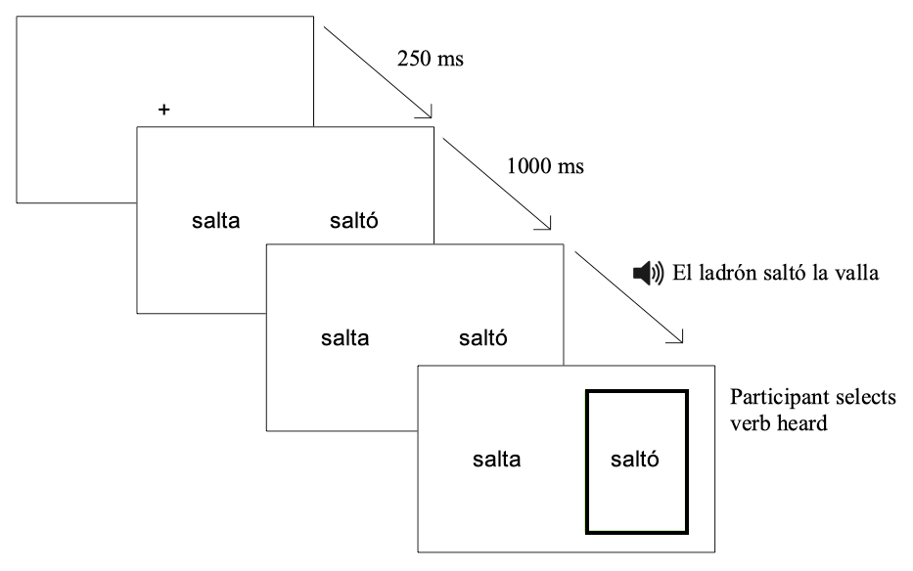

*Figure* *1*. Sample trial of the eye-tracking prediction task

**4.3.2. Visuospatial anticipation task.** Participants first received the instructions for the task, completed the two practice trials and asked questions about the procedure. In the practice trials, participants saw the car’s position upon pressing the spacebar as feedback in the first two trials, to learn if they had timed the key press correctly with the speed of the car. In the last two practice trials, they did not receive any feedback or saw the car upon pressing the spacebar, imitating the procedure in the experimental trials. In the experimental trials, the trial would automatically finish upon the spacebar press. There was a fixation cross for 250 ms between trials. Figure 2 represents a trial of the task.

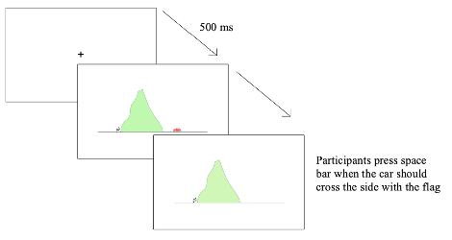

*Figure* *2*. Sample trial of the visuospatial anticipation task

**4.3.3. Corsi task.** Participants first received instructions, completed two practice sets, and asked questions. In each trial, both practice and experimental, participants saw flashing squares and recreated the sequences of flashing squares by left-clicking on them with the mouse. Once they had clicked the same number of squares as in the original sequence, a fixation cross appeared for 500 ms in the center of the screen, and the next trial with a new sequence started. The task automatically moved to the next set of three sequences one-square longer upon completion of a level (see Figure 3 for a sample trial). No feedback was provided throughout the task.

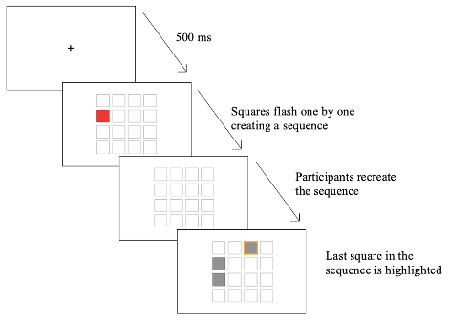

*Figure* *3*. Sample trial of the Corsi-blocks tapping task

**4.3.4. Ospan task.** The OSpan task was divided into practice and experimental trials. For each trial, participants first heard a word in their L1 and then heard a simple equation, like 2+2=5, also in their L1. During the equation, participants saw the words TRUE or FALSE on each side of the screen, and they had to press the corresponding key (left-shift key for the word on the left, right-shift key for the word on the right) depending on whether the equation was correct or not. After each equation, they saw a fixation point for 500 ms and another pair of word-equation was presented. This process was repeated until the word RECALL or a linguistic equivalent in the L1 of the participant was shown on the screen, at which moment participants had to write on paper the words they had heard in the order they were presented. The task started with three sets of three trials, then three sets of four trials, and so on until the third set of six trials. Figure 4 shows a sample trial.

*Figure* *4*. Sample trial of the Ospan task

## 4.4. Data analysis

Statistical analyses were conducted on R (Team & others, 2013) with the packages *lme4* (Bates, Mächler, Bolker, & Walker, 2014). The gaze fixation data were downsampled to 50 ms bins and incorrect responses were filtered out (0.42% of data). The data were centered 200 ms after the onset of the last syllable to account for saccade planning and launching, as is standard procedure in auditory eye-tracking studies (e.g., Fischer, 1992; Saslow, 1967).

Growth curve analyses (GCA, Mirman, 2016) with mixed-effects were used to analyze the time window around the verb encompassing the departure of looks from chance levels. The time window spanned from 400 ms before to 200 ms after the center of our data. These GCA analyses resulted in 9 different models—three for each L1 population. One of these models was for visuospatial anticipation abilities, a second one for vPS, and a third one for sPS. The L1 populations, visuospatial measures and vPS were separated to avoid overfitting and to avoid making the results uninterpretable.

Main effects and interactions were assessed by means of nested model comparisons. We tested linear, quadratic and cubic orthogonal polynomial time terms to model the time course in the GCA. The outcome data, proportion of fixations on the target at the onset of the last syllable on the verb from the eye-tracking prediction task, was modified using the empirical logic transformation, as it is binary data (fixations on the target or the distractor; Barr, 2008).

The three GCA for the monolinguals included lexical stress, the time terms and visuospatial prediction abilities, sPS or vPS as fixed effects, and participant and item as random intercepts, and lexical stress as random slope. The GCA for the L2 speakers were modeled with lexical stress, the time terms, L2 proficiency and visuospatial prediction abilities or verbal or visuospatial processing speed as fixed effects, and participant and item as random intercepts, and lexical stress as random slope. Lexical stress was categorical and contrast-coded. The continuous variable L2 proficiency was standardized. Visuospatial prediction abilities values were obtained by calculating the time difference (timing) between participants’ key presses and the ms when the car should reappear, and then we estimated a measure of visuospatial anticipation for each participant via the random effects of a separate model estimating key-press time as a function of speed and direction. That is, individual divergences from the model estimate are taken as an assessment of visualspatial anticipation for subsequent models. These values could therefore be negative if participants tended to press too soon, or positive if pariticipants tended to wait too long. Trials where the participant took too long to respond and the car should have ‘left’ the screen were discarded. Verbal and visuospatial processing speed values were obtained by measuring the time participants needed in correct trials, and then applying a linear regression to these values where they were the outcome and length of the trial (in terms of words/squares to remember) as predictors and calculating the random effects for each participant.

# 5. Results

Model summaries can be found in Appendices 2 (monolingual speakers), 3 (English speakers), and 4 (Mandarin Chinese speakers). Figure 5 shows the time course of participants’ fixations on the targets during our time window. As observed, monolingual speakers start to direct their gaze to the target above chance before the L2 groups; the L2 groups increase their fixations on the target at the same time. All three groups are fixating on the target above chance at the onset of the last syllable in the verbs—the syllable containing the suffix to be predicted.

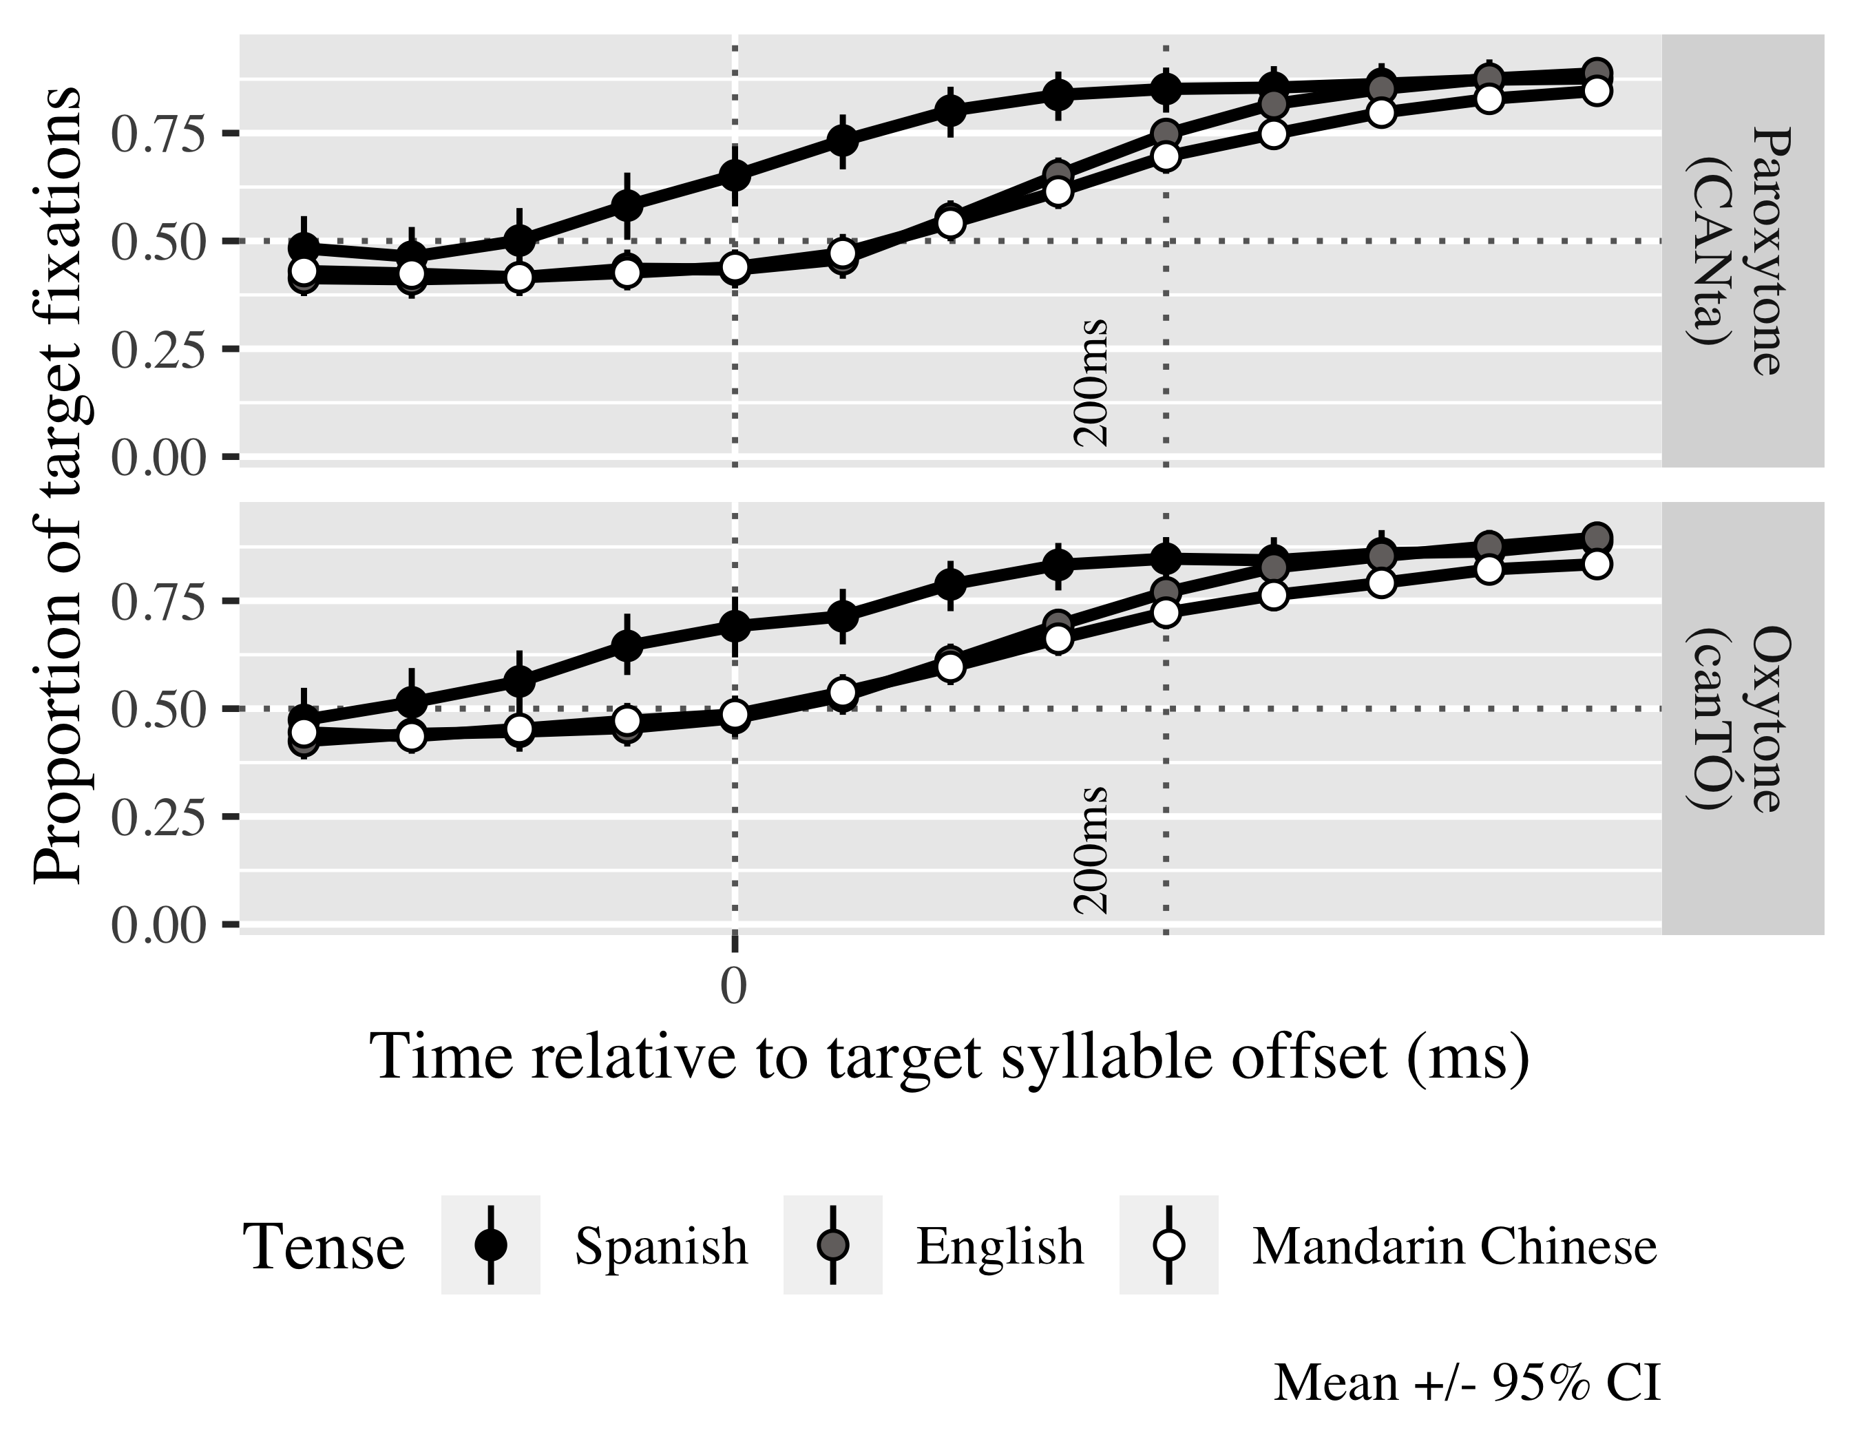

*Figure* *5*. Time course of fixations on the target verb.

## Monolinguals

The first model for each population considered vPS. The second model focused on sPS. The last model focused on the visuospatial prediction timings.

Tables 2, 3 and 4 contain the estimated probabilities of Spanish monolinguals fixating on the linguistic target in the vPS, sPS and visuospatial prediction GCAs respectively in each condition. As seen, all speakers regardless of their vPS fixate above chance upon last syllable onset on the target verbs. We take the number of fixations above chance even on the lower bound as evidence that monolinguals were predicting the suffix upon hearing an initial stressed or unstressed syllable.

| Lexical stress | Verbal processing speed | Probability | Lower bound | Upper bound |
| --- | --- | --- | --- | --- |
| paroxytone | -1 | 0.84 | 0.80 | 0.87 |
|  | 0 | 0.88 | 0.85 | 0.90 |
|  | 1 | 0.91 | 0.89 | 0.93 |
| oxytone | -1 | 0.91 | 0.89 | 0.93 |
|  | 0 | 0.88 | 0.85 | 0.90 |
|  | 1 | 0.84 | 0.80 | 0.87 |

*Table 2.* Model estimates for probability of target fixations ±SE in monolinguals at 200 ms after the first syllable offset (vPS GCA).

| Lexical stress | Visuospatial processing speed | Probability | Lower bound | Upper bound |
| --- | --- | --- | --- | --- |
| paroxytone | -1 | 0.87 | 0.84 | 0.90 |
|  | 0 | 0.88 | 0.85 | 0.90 |
|  | 1 | 0.88 | 0.86 | 0.91 |
| oxytone | -1 | 0.88 | 0.86 | 0.91 |
|  | 0 | 0.88 | 0.85 | 0.90 |
|  | 1 | 0.87 | 0.84 | 0.90 |

*Table 3.* Model estimates for probability of target fixations ±SE in monolinguals at 200 ms after the first syllable offset (sPS GCA).

| Lexical stress | Visual prediction timing | Probability | Lower bound | Upper bound |
| --- | --- | --- | --- | --- |
| paroxytone | -1 | 0.85 | 0.80 | 0.88 |
|  | 0 | 0.88 | 0.85 | 0.90 |
|  | 1 | 0.91 | 0.88 | 0.93 |
| oxytone | -1 | 0.91 | 0.88 | 0.93 |
|  | 0 | 0.88 | 0.85 | 0.90 |
|  | 1 | 0.85 | 0.80 | 0.88 |

*Table 4*. Model estimates for probability of target fixations ±SE in monolinguals at 200 ms after the first syllable offset (visuospatial prediction GCA).

The linear (γ10 = 4.14; SE = 0.44; *t* = 9.31; *p* < .001), quadratic (γ20 = 0.18; SE = 0.25; *t* = 0.75; *p* = .455) and cubic (γ30 = −0.35; SE = 0.21; *t* = −1.68; *p* = .092) polynomial time terms reflected the curves of the fixation patterns and were kept in the models. The log odds of monolinguals fixating on the target were *γ*00 = 1.32 (proportion: .79) (statistics given for the vPS model; the statistics for the other two models hover at similar values, see Appendix 2). In the vPS GCA, there was an interaction between stress pattern and vPS in the linear (χ2(1) = 5.02, *p* = 0.025) and cubic time terms (χ2(1) = 20.66, *p* = 0.000). Specifically, those individuals with faster processing speed (shorter reaction times) predicted paroxytones slower than slower individuals (γ11 = −0.39; SE = 0.20; *t* = −1.98; *p* = .048), as can be seen in the steeper solid line in Figure 6, but earlier (γ31 = 0.87; SE = 0.19; *t* = 4.57; *p* < .001) than those monolinguals with slower processing speed, while the opposite case happen in slower individuals, in that they predicted oxytones earlier but more slowly.

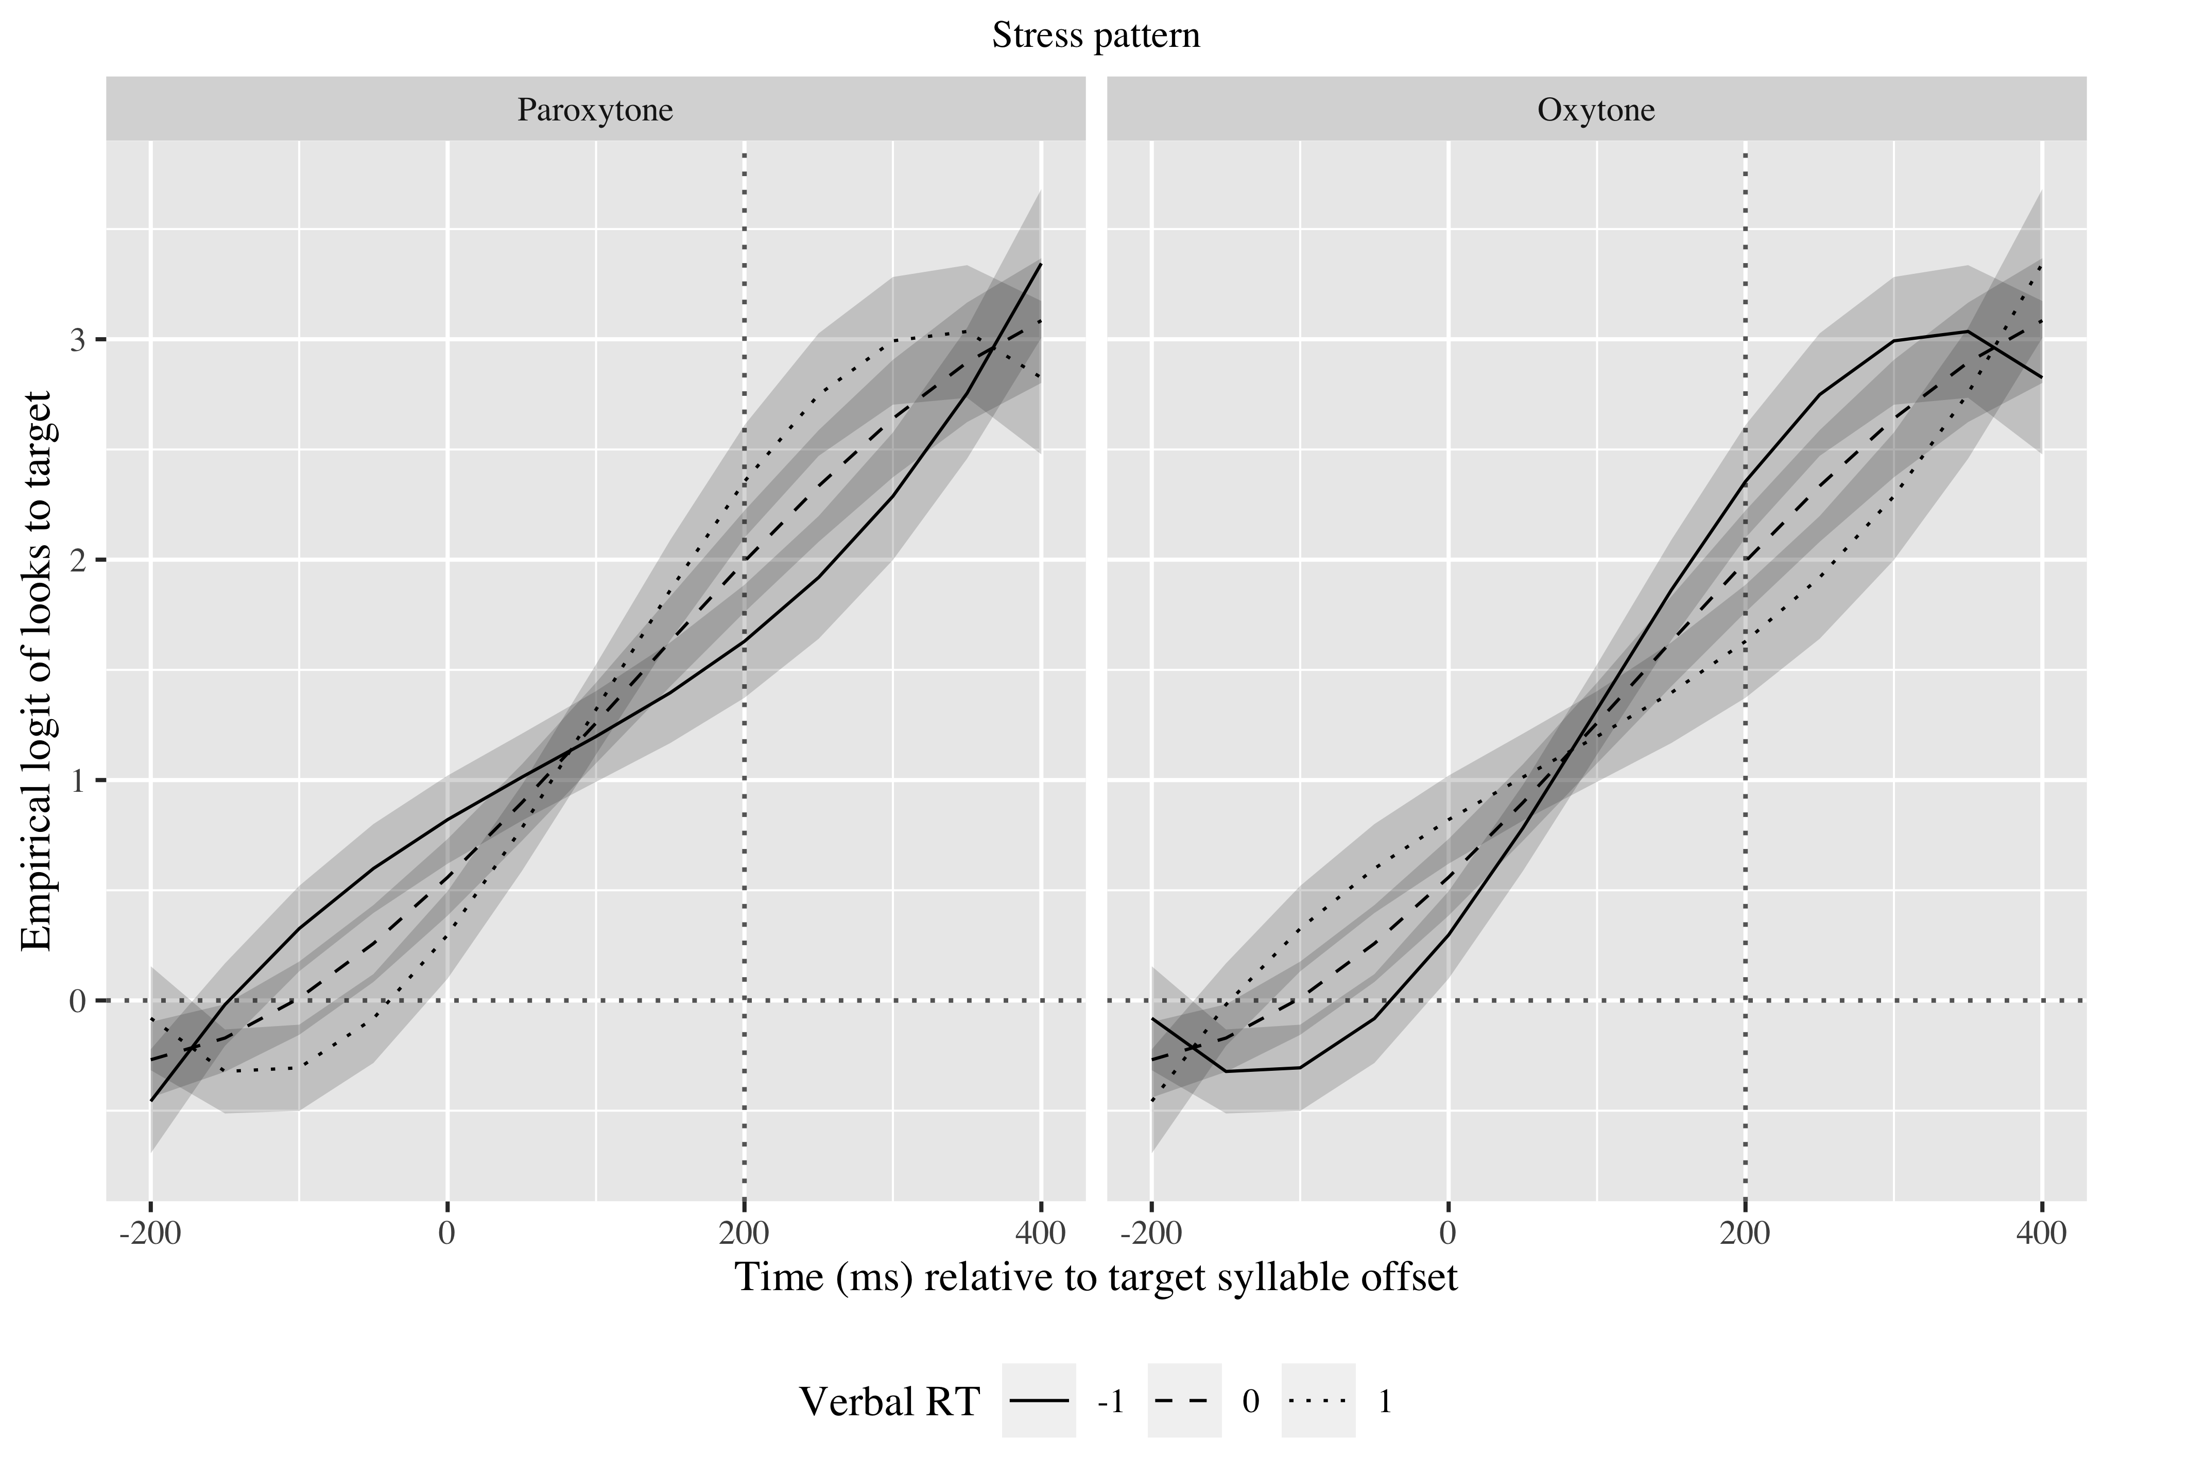

*Figure* *6*. Growth curve estimates of target fixations as a function of vPS for L1 Spanish speakers according to stress pattern during the analysis window. Symbols and lines represent model estimates, and the transparent ribbons represents ±SE. Empirical logit values on y-axis correspond to proportions of 0.12, 0.50, 0.88, and 0.98. The horizontal dotted line represents the 50% probability of fixating on the target. The vertical dotted line indicates 200 ms after the offset of the first syllable of the verb.

In the sPS GCA, there was an interaction between stress pattern and sPS in the quadratic (χ2(1) = 4.94, *p* = 0.026) and cubic (χ2(1) = 5.93, *p* = 0.015) time terms. As observed in Figure 7, shorter reaction times were associated with faster increase of fixations on the paroxytone condition and longer reaction times on the oxytone condition (γ31 = 0.32; SE = 0.13; *t* = 2.46; *p* = .014).

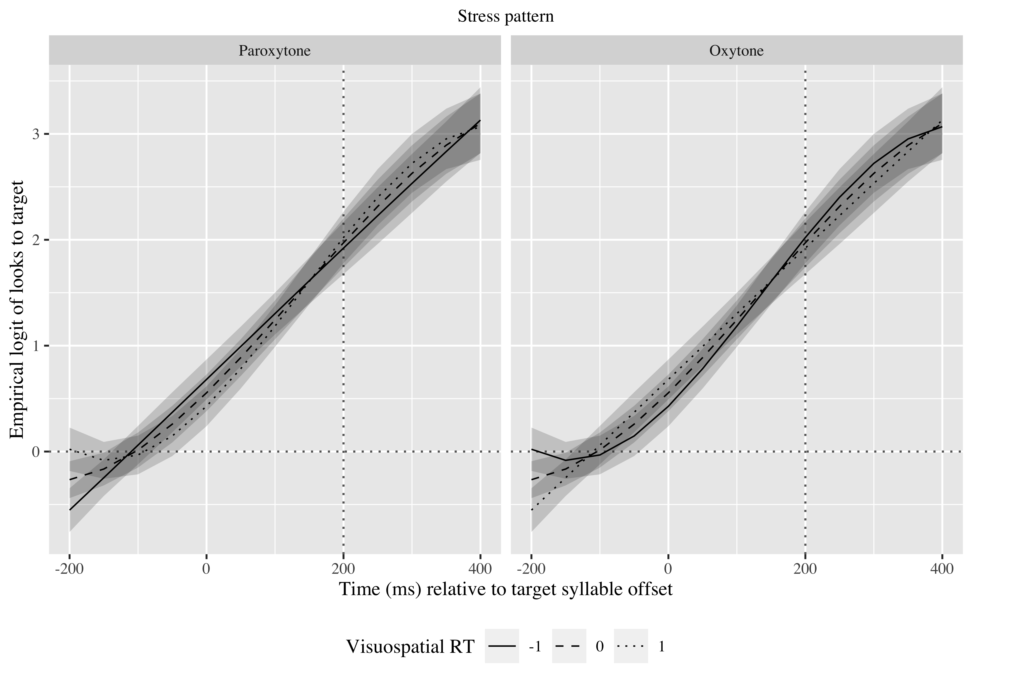

*Figure* *7.* Growth curve estimates of target fixations as a function of sPS for L1 Spanish speakers according to stress pattern during the analysis window. Symbols and lines represent model estimates, and the transparent ribbons represents ±SE. Empirical logit values on y-axis correspond to proportions of 0.12, 0.50, 0.88, and 0.98. The horizontal dotted line represents the 50% probability of fixating on the target. The vertical dotted line indicates 200 ms after the offset of the first syllable of the verb.

Lastly, in the visuospatial prediction GCA, there was an interaction between stress pattern and visuospatial prediction ability in the linear term (χ2(1) = 4.76, *p* = 0.029). Figure 8 shows that speakers who tended to anticipate the car’s reappearance on the shorter end predicted oxytones faster than those who predicted its reappearance later (γ11 = −1.01; SE = 0.46; *t* = −2.20; *p* = .028).

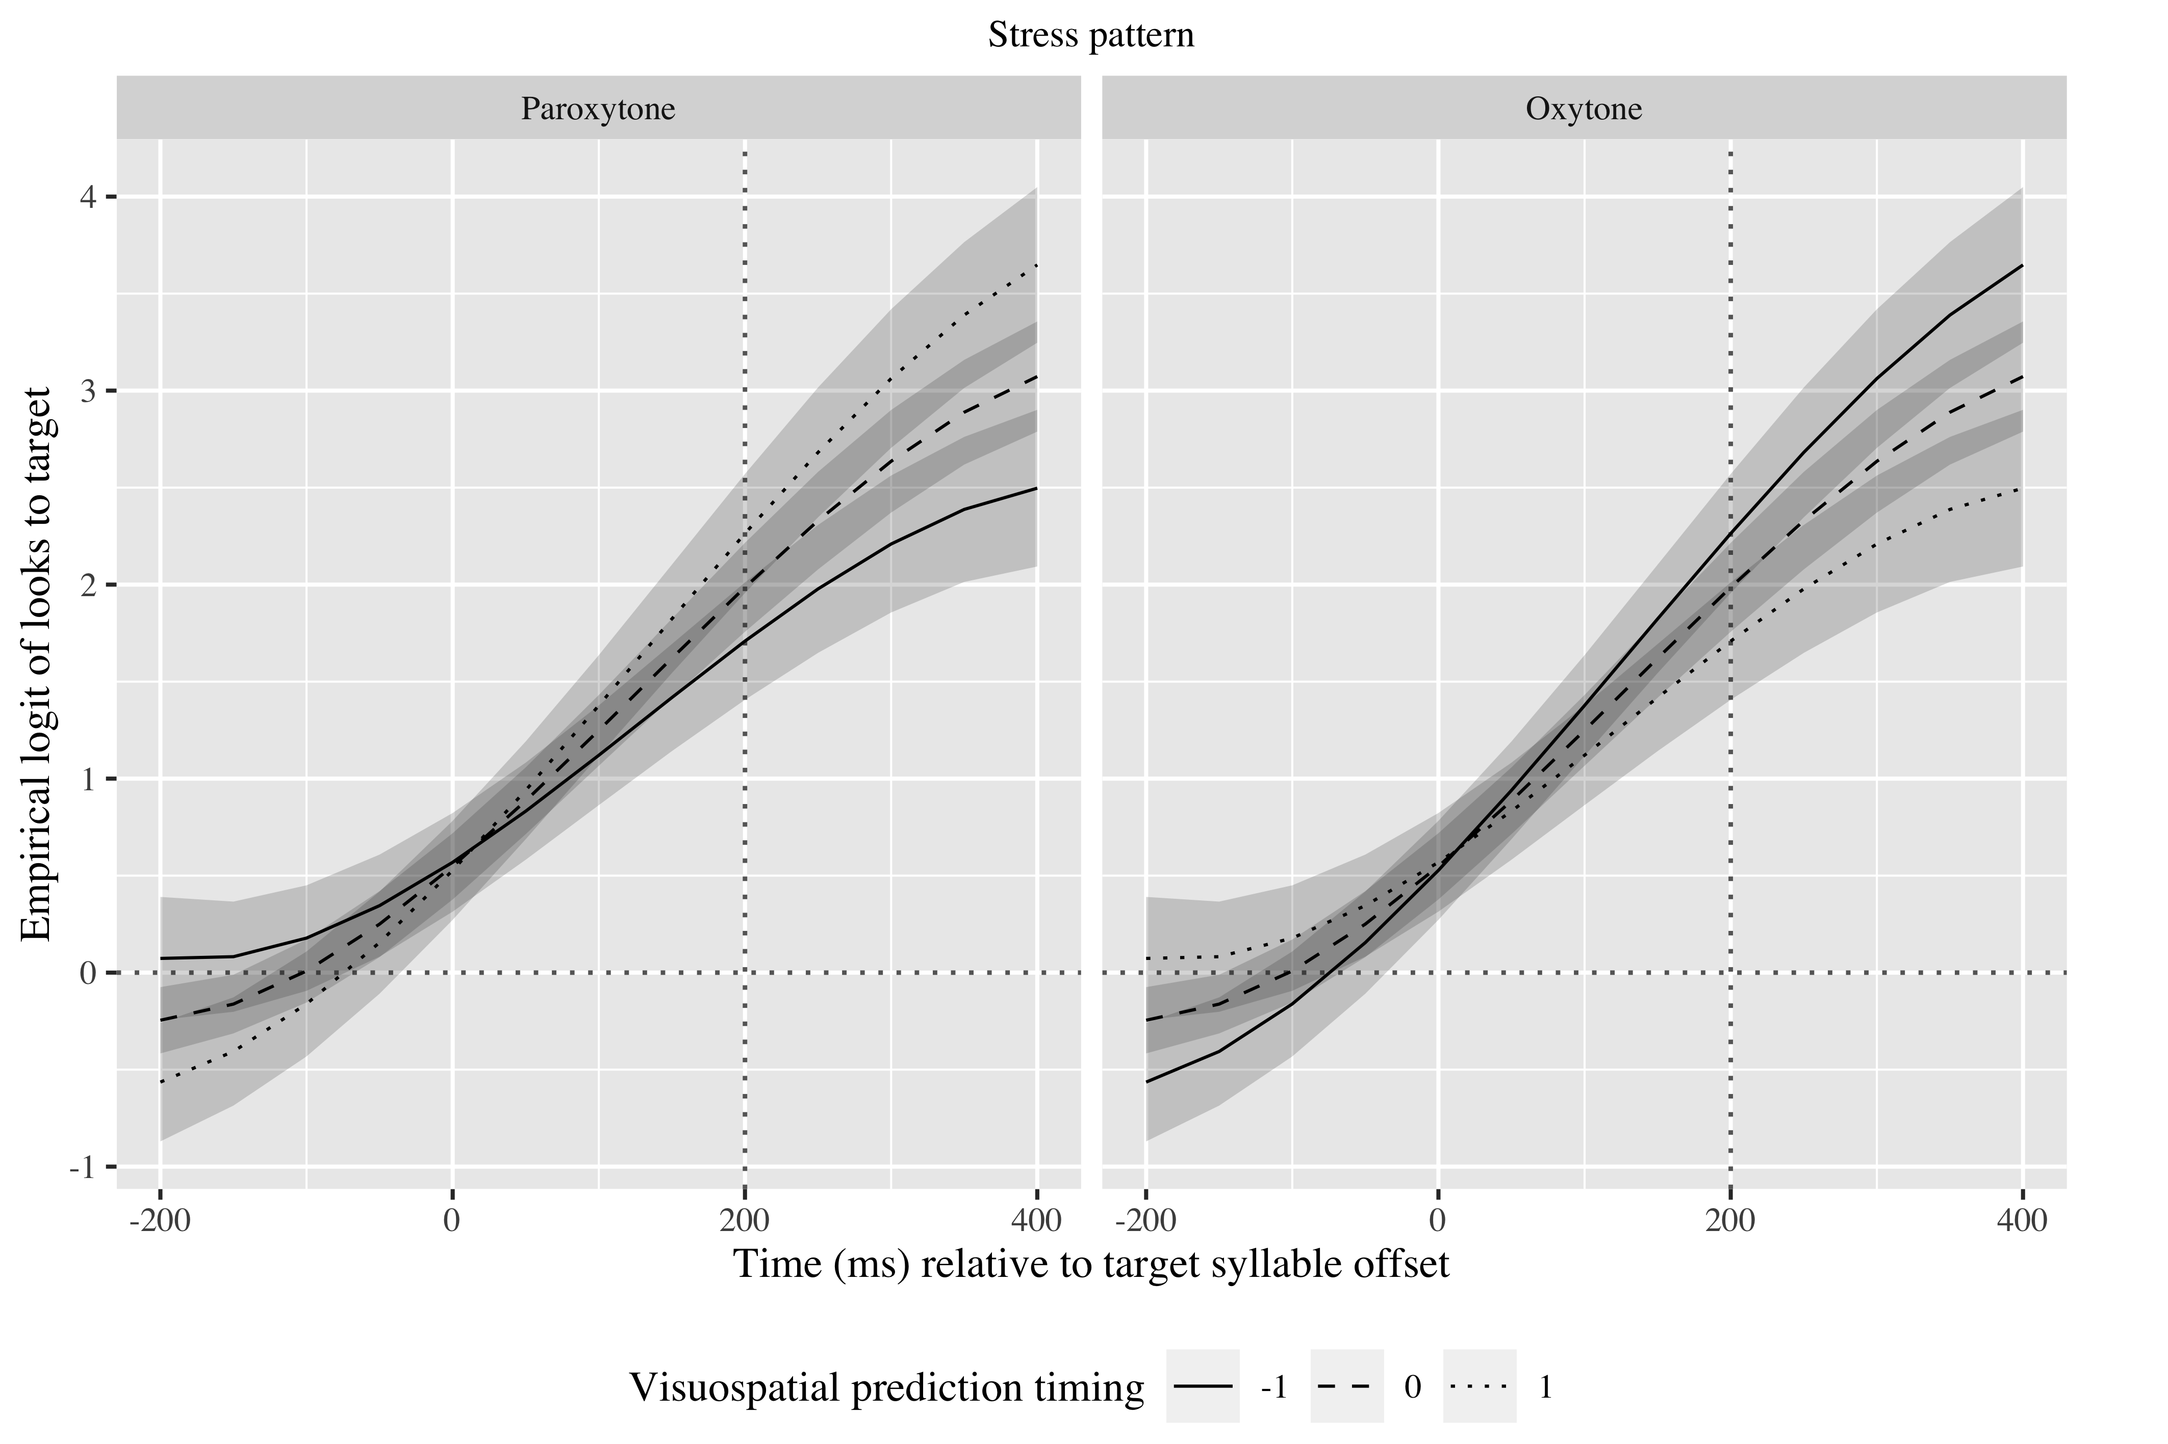

*Figure* *8*. Growth curve estimates of target fixations as a function of visuospatial prediction for L1 Spanish speakers according to stress pattern during the analysis window. Symbols and lines represent model estimates, and the transparent ribbons represents ±SE. Empirical logit values on y-axis correspond to proportions of 0.12, 0.50, 0.88, and 0.98. The horizontal dotted line represents the 50% probability of fixating on the target. The vertical dotted line indicates 200 ms after the offset of the first syllable of the verb.

## English speakers

For English speakers, all three time terms were kept (linear: γ10 = 3.92; SE = 0.28; *t* = 13.89; *p* < .001; quadratic: γ20 = 1.28; SE = 0.19; *t* = 6.76; *p* < .001; cubic: γ30 = −0.28; SE = 0.14; *t* = −2.02; *p* = .044). The vPS GCA calculates the log odds of English speakers fixating on the Spanish targets at *γ*00 = 0.73 (proportion: .68) (see Appendix 3 for the exact values in the visuospatial prediction GCA). Tables 5 and 6 show the probabilities of English speakers fixating on the targets in each condition in the vPS and the visuospatial prediction GCAs. As monolinguals, they are fixating above chance, suggesting they are anticipating the suffixes.

| Lexical stress | Proficiency | Verbal processing speed | Probability | Lower bound | Upper bound |
| --- | --- | --- | --- | --- | --- |
| paroxytone | -1 | -1 | 0.73 | 0.69 | 0.77 |
|  |  | 0 | 0.67 | 0.64 | 0.71 |
|  |  | 1 | 0.61 | 0.55 | 0.67 |
|  | 0 | -1 | 0.77 | 0.73 | 0.81 |
|  |  | 0 | 0.72 | 0.68 | 0.75 |
|  |  | 1 | 0.65 | 0.60 | 0.71 |
|  | 1 | -1 | 0.80 | 0.77 | 0.84 |
|  |  | 0 | 0.75 | 0.72 | 0.78 |
|  |  | 1 | 0.70 | 0.64 | 0.75 |
| oxytone | -1 | -1 | 0.80 | 0.76 | 0.83 |
|  |  | 0 | 0.75 | 0.71 | 0.78 |
|  |  | 1 | 0.69 | 0.64 | 0.74 |
|  | 0 | -1 | 0.83 | 0.79 | 0.86 |
|  |  | 0 | 0.78 | 0.76 | 0.81 |
|  |  | 1 | 0.73 | 0.68 | 0.78 |
|  | 1 | -1 | 0.86 | 0.82 | 0.88 |
|  |  | 0 | 0.82 | 0.79 | 0.84 |
|  |  | 1 | 0.77 | 0.72 | 0.81 |

*Table 5*: Model estimates for probability of target fixations ±SE in English speakers at 200 ms after the offset of the first syllable in the targets (vPS GCA).

| Lexical stress | Proficiency | Visual prediction timing | Probability | Lower bound | Upper bound |
| --- | --- | --- | --- | --- | --- |
| paroxytone | -1 | -1 | 0.74 | 0.68 | 0.79 |
|  |  | 0 | 0.68 | 0.65 | 0.72 |
|  |  | 1 | 0.62 | 0.56 | 0.68 |
|  | 0 | -1 | 0.72 | 0.69 | 0.75 |
|  |  | 0 | 0.72 | 0.69 | 0.75 |
|  |  | 1 | 0.72 | 0.69 | 0.75 |
|  | 1 | -1 | 0.70 | 0.65 | 0.76 |
|  |  | 0 | 0.76 | 0.73 | 0.79 |
|  |  | 1 | 0.81 | 0.76 | 0.84 |
| oxytone | -1 | -1 | 0.70 | 0.64 | 0.76 |
|  |  | 0 | 0.76 | 0.72 | 0.79 |
|  |  | 1 | 0.80 | 0.76 | 0.84 |
|  | 0 | -1 | 0.79 | 0.76 | 0.81 |
|  |  | 0 | 0.79 | 0.76 | 0.81 |
|  |  | 1 | 0.79 | 0.76 | 0.81 |
|  | 1 | -1 | 0.86 | 0.82 | 0.89 |
|  |  | 0 | 0.82 | 0.79 | 0.84 |
|  |  | 1 | 0.78 | 0.72 | 0.82 |

*Table 6*: Model estimates for probability of target fixations ±SE in English speakers at 200 ms after offset of the first syllable in the targets (visuospatial prediction GCA).

In the vPS GCA, there was an effect of proficiency on the linear term (χ2(1) = 11.38, *p* = .001), such that higher proficiency resulted in a faster increase of fixations on the targets (γ11 = 0.68; SE = 0.18; *t* = 3.86; *p* < .001). There was a main effect of stress pattern on the quadratic term (χ2(1) = 4.23, *p* = .040), indicating that oxytones were predicted earlier than paroxytones (γ21 = −0.28; SE = 0.13; *t* = −2.19; *p* = .028). Finally, there was an effect of vPS on the linear term (χ2(1) = 4.03, *p* = .045), revealing that individuals with faster processing speed predicted linguistic targets faster (γ13 = −0.88; SE = 0.42; *t* = −2.10; *p* = .036) (see Figure 9).

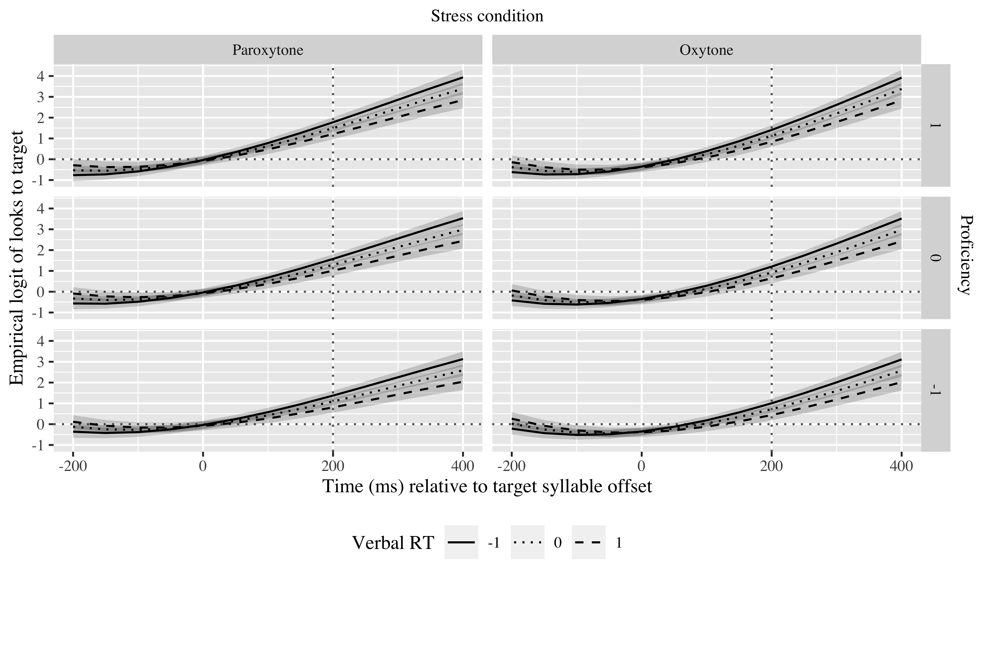

*Figure* *9*. Growth curve estimates of target fixations as a function of vPS for L1 English speakers according to stress pattern during the analysis window. Symbols and lines represent model estimates, and the transparent ribbons represents ±SE. Empirical logit values on y-axis correspond to proportions of 0.12, 0.50, 0.88, and 0.98. The horizontal dotted line represents the 50% probability of fixating on the target. The vertical dotted line indicates 200 ms after the offset of the first syllable of the verb.

In the visuospatial prediction GCA, the effects of proficiency and stress pattern appeared again, and there was also an interaction between visuospatial prediction abilities, proficiency, and stress pattern in the linear (χ2(1) = 6.99, *p* = .008) and quadratic (χ2(1) = 4.25, *p* = .039) time terms. As Figure 10 shows, faster visuospatial prediction helped faster linguistic prediction in paroxytones at a lower proficiency and oxytones at a high proficiency (γ13 = −1.12; SE = 0.39; *t* = −2.85; *p* = .004) with slower visuospatial prediction facilitating faster increase of fixations on paroxytones at high proficiency and on oxytones at low proficiency (γ23 = −0.77; SE = 0.37; *t* = −2.07; *p* = .039).

There was no effect of or interaction with sPS.

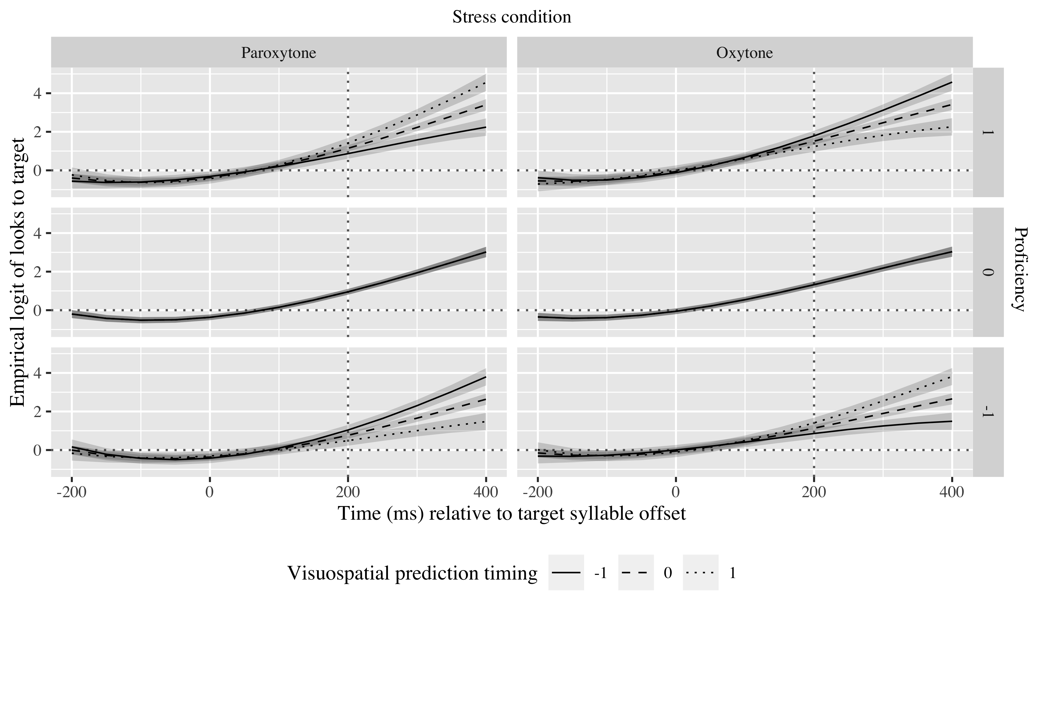

*Figure* *10*. Growth curve estimates of target fixations as a function of visuospatial prediction for L1 English speakers according to stress pattern during the analysis window. Symbols and lines represent model estimates, and the transparent ribbons represents ±SE. Empirical logit values on y-axis correspond to proportions of 0.12, 0.50, 0.88, and 0.98. The horizontal dotted line represents the 50% probability of fixating on the target. The vertical dotted line indicates 200 ms after the offset of the first syllable of the verb.

## Mandarin Chinese speakers

The three time terms were kept here again (linear: γ10 = 2.86; SE = 0.23; *t* = 12.42; *p* < .001; quadratic: γ20 = 1.00; SE = 0.14; *t* = 7.03; *p* < .001; cubic: γ30 = −0.13; SE = 0.12; *t* = −1.12; *p* = .261). The sPS GCA calculates the log odds of Mandarin Chinese speakers fixating on the Spanish targets at *γ*00 = 0.56 (proportion: .64). Table 7 shows the probabilities of English speakers fixating on the targets in each condition in the sPS GCA. As the other two populations, they are fixating above chance, suggesting they are anticipating the suffixes.

| Lexical stress | Proficiency | Visuospatial processing speed | Probability | Lower bound | Upper bound |
| --- | --- | --- | --- | --- | --- |
| paroxytone | -1 | -1 | 0.63 | 0.59 | 0.66 |
|  |  | 0 | 0.66 | 0.64 | 0.69 |
|  |  | 1 | 0.70 | 0.67 | 0.73 |
|  | 0 | -1 | 0.65 | 0.62 | 0.69 |
|  |  | 0 | 0.69 | 0.67 | 0.71 |
|  |  | 1 | 0.73 | 0.70 | 0.75 |
|  | 1 | -1 | 0.68 | 0.64 | 0.71 |
|  |  | 0 | 0.72 | 0.69 | 0.74 |
|  |  | 1 | 0.75 | 0.72 | 0.77 |
| oxytone | -1 | -1 | 0.63 | 0.59 | 0.66 |
|  |  | 0 | 0.66 | 0.64 | 0.69 |
|  |  | 1 | 0.70 | 0.67 | 0.73 |
|  | 0 | -1 | 0.65 | 0.62 | 0.69 |
|  |  | 0 | 0.69 | 0.67 | 0.71 |
|  |  | 1 | 0.73 | 0.70 | 0.75 |
|  | 1 | -1 | 0.68 | 0.64 | 0.71 |
|  |  | 0 | 0.72 | 0.69 | 0.74 |
|  |  | 1 | 0.75 | 0.72 | 0.77 |

*Table 7*: Model estimates for probability of target fixations ±SE in Mandarin Chinese speakers at 200 ms after the offset of the first syllable in the linguistic targets (vPS GCA).

There was an effect of proficiency on the intercept (χ2(1) = 4.02, *p* = 0.045), which indicates that higher proficiency contributed to more fixations, that is, a higher probability of prediction (γ01 = 0.12; SE = 0.06; *t* = 2.08; *p* = .038). There was an effect of sPS on the linear time term (χ2(1) = 7.56, *p* = 0.006), pointing that those individuals more conservative on their reaction time predicted linguistic targets faster (γ11 = 0.58; SE = 0.20; *t* = 2.84; *p* = .004), as observed in the steeper slopes in Figure 11. No other effects of sPS, visuospatial prediction or vPS were found in the Mandarin Chinese speakers.

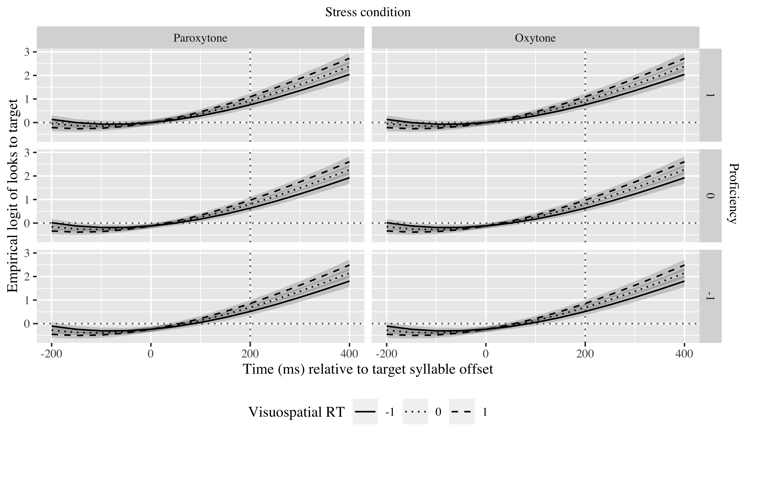

*Figure* *11*. Growth curve estimates of target fixations as a function of sPS for L1 Mandarin Chinese speakers according to stress pattern during the analysis window. Symbols and lines represent model estimates, and the transparent ribbons represents ±SE. Empirical logit values on y-axis correspond to proportions of 0.12, 0.50, 0.88, and 0.98. The horizontal dotted line represents the 50% probability of fixating on the target. The vertical dotted line indicates 200 ms after the offset of the first syllable of the verb.

**6. Discussion**

We set out to examine prediction transfer effects from the visuospatial domain to language and mediation of verbal and visuospatial processing speed. Monolingual Spanish speakers and Mandarin and English learners of Spanish completed linguistic and visuospatial linguistic tasks and verbal and visuospatial working memory tasks that also measured processing speed. The results show that 1) both vPS and sPS as well as visuospatial prediction abilities affect language prediction in monolinguals, 2) vPS and visuospatial prediction affect language prediction in English speakers of Spanish, and 3) only sPS affects language prediction in Mandarin speakers of Spanish. These results suggest that language prediction is interconnected with domain-general and domain-specific mechanisms typically secondary in the language domain.

## L1 speakers

We hypothesized that vPS and sPS would influence linguistic prediction, but visuospatial prediction would not. Our results on vPS and sPS confirm our predictions, but the results on visuospatial prediction do not. Monolinguals with faster vPS predicted paroxytones more slowly but earlier than monolinguals with slower vPS. Faster vPS may facilitate earlier increase of fixations on paroxytones because of the advantage provided by the more lively processing, but the lack of confirmatory information is causing the slowed down prediction. Slower vPS, in contrast, may facilitate earlier prediction of oxytones because they are a less common stress pattern in Spanish than paroxytones (Morales-Font, Núñez, Colina, & Bradley, 2014), but the slower processing speed has not provided enough information to discard all wrong alternatives, making prediction of oxytones slow down in comparison to paroxytones.

These results add up to Huettig and Janse (2016)’s findings, showing that measures other than working memory may also influence prediction. Huettig and Janse (2016) discovered that vPS positively influences linguistic prediction. Our findings expand that finding by suggesting the the association between vPS and linguistic prediction is not straightforward and other factors such as how common the structure to be anticipated is also play a role.

Faster sPS was associated with faster prediction in the paroxytone condition, while slower sPS was associated with faster prediction in the oxytone condition. The causes of this double association may be different for each side of the association. Individuals with faster sPS may recruit it as the last push to help choose the paroxytone target, given the large amount of competitors. In the oxytone condition, recruiting sPS may not be necessary as that condition may be “too easy.” Individuals with slower sPS may recruit it only in the oxytone condition because the paroxytone one is too complex.

Lastly, those individuals who tended to anticipate the car’s reappearance too early predicted paroxytones faster, while those who tended to wait longer predicted oxytones faster. If speakers who predict visuospatial information too early do so to be conservative and make sure they do not miss the event, they may be choosing paroxytones faster because it is the most probably outcome. In turn, speakers who are not as conservative and do not feel the need to predict too far in advance the car’s reappearance may predict oxytones faster because they know there are fewer competitors, reducing the costs of discarding wrong alternatives.

The different effects of our predictors on linguistic prediction shed light into individual differences in monolinguals. Previous research had failed to show differences in prediction based on stress pattern (Sagarra & Casillas, 2018; e.g., Fernandez Arroyo et al., under review). Although overall there was no difference in prediction across stress patterns here either, the relationship between vPS, sPS and visuospatial prediction with linguistic prediction indicate that there may be hidden differences that are only revealed when more subtly recruited cognitive capacities are examined.

Our findings of the influence of sPS and visuospatial prediction abilities on linguistic prediction also suggest that, at least in an L1, linguistic prediction abilities are not cognitively isolated, but rather, are part of a larger network that can be recruited depending on the abilities of the speaker and the cognitive load of the message. These findings support domain-general approaches to language prediction arguing that skills from other domains may be transferred to unrelated or nearly unrelated domains, as long as the skills depend on similar perceptual or conceptual information (Singley & Anderson, 1989), which would be prediction in our case. Our findings thus further support those scholar advocating for the adoption of a more holistic approach in language research (e.g., Ellis, 2019; Ryskin, Levy, & Fedorenko, 2020), for whom the investigation of language learning, and by extension processing, should include the usages, the contents, the participants, and the contexts of the speakers (Ellis, 2019)

## L2 speakers

We had hypothesized vPS and sPS would influence their linguistic prediction abilities, but visuospatial prediction abilities would not. In the English speakers, vPS did exert some influence and so did visuopatial prediction abilities, but sPS did not. Proficiency and stress pattern also determined linguistic prediction.

As proficiency increased, predicted became faster, probably as a result of more stable associations between stress patterns and tense suffixes. However, the finding that oxytones were predicted earlier than paroxytones suggest that oxytones were easier to start anticipating. This difference across stress patterns may also stem from the probability of each happening. As paroxytones are more typical (Morales-Font, Núñez, Colina, & Bradley, 2014), the number of possible competitors to the target is larger, delaying target activation. These findings on proficiency and stress pattern align with previous research similarly showing that proficiency positively contributes to prediction and that oxytones tend to be easier to anticipate than paroxytones for L2 speakers (e.g., Fernandez Arroyo et al., under review).

The effect of vPS was that as it became faster, prediction also turned quicker. This association makes sense as, the faster a speaker is able to process linguistic information, the earlier the new information makes sense in the current context, affording the speaker to have enough information to choose the target faster.

As for visuospatial prediction, it interacted with proficiency and stress pattern. In lower proficiency participants, those who anticipated the car’s reappearance too early predicted paroxytones faster and oxytones more slowly, in comparison to those who tended to wait too long. As proficiency increased, the relationship reversed. When proficiency is not too high, speakers who predict visuospatial events too early may predict paroxytones faster because they are relying on the most typical, and therefore reliable, stress pattern. Those who are more conservative and predict the car’s reappearance later may predict oxytones faster because they know they have fewer competitors, and are therefore more self-confident in their word selection. At high levels of proficiency, the situation may reverse due to overdoing it. That is, speakers who predict visuospatial events too early may have learned to rely on the fewer number of competitors, and those who predict too late may have learned that paroxytones are more typical, and therefore are able to use the paroxytone structure faster, but in both cases, both groups may not have been able to reach a balance between both conditions. Our results do not allow us to ascertain whether this balance is attainable or not through anticipatory experience (i.e., in interpreters) or immersion experience, or whether, on the contrary, the balance is never achieved in late L2 speakers, more in line with the critical period hypothesis.

In the Mandarin Chinese speakers, only sPS affected language prediction. In contrast to the English speakers, only proficiency additionally determined prediction. Specifically, as proficiency increased, so did their chance at prediction, but not the timing or the speed. In terms of sPS, those with faster sPS actually predicted language more slowly. Since bilinguals with a logosyllabic writing system benefit more from enhanced visuospatial working memory than alphabetic bilinguals (Ma, 2016), sPS may also affect populations used to logosyllabic writing systems more strongly. Consequently, given that Mandarin Chinese may require sPS more often than Spanish or English in reading due to the nature of their writing system, this population may recruit sPS more readily, even when it is not necessary, making its relationship with language prediction more visible. However, their automatic recruitment of sPS when it was not needed may have hindered prediction, as they may have been expecting to receive more information that never came, as visuospatial information is not as common in Spanish.

These findings extend those on reading (e.g., Lin, Sun, & Zhang, 2016), visuospatial representation (Holmes, Moty, & Regier, 2017) and processing (e.g., Landau & Hoffman, 2005), by adding another overlap between the visuospatial and linguistic domains, namely, prediction. This overlap and the influence of domain-general capacities indicate once more that language is subject to other cognitive abilities, and that skills acquired in language are potentially transferable to other domains and vice versa (Anderson, 1990; Thorndike, 1901). Future research should therefore adopt a more comprehensive perspective that considers language as part of something bigger, rather than as an isolated cognitive domain. The different effects of each predictor in our three populations further suggests that the transfer is not straight-forward nonetheless. Factors such as nature of the linguistic system (L1 vs. L2) or the L1 may condition how prediction skills are transferred or affected by general cognitive abilities.

Future studies should explore what factors affect skill transfer in prediction. Similarly, future studies should investigate whether the strength of the association across domains varies depending on the origin domain and what factors condition the strength of the association, such as expertise or modality. This future research will help fine-tune our knowledge about linguistic prediction.

# 7. Conclusion

In this study we asked whether there would be transfer from the visuospatial domain to speech to facilitate prediction of suffixes associated to lexical stress cues in L1 and L2 English and Mandarin speakers of Spanish, and whether verbal and visuospatial processing speed would mediate linguistic prediction. The results demonstrate that linguistic prediction is connected with domain-general and domain-specific abilities, even across modalities, as long as there is some commonality in the skill serving as connection. The connection presents different characteristics in different linguistic populations, although all showed evidence of associations of language with the visuospatial domain. Our findings support domain-general cognitive approaches to language.

# References

Altmann, G. T., & Kamide, Y. (1999). Incremental interpretation at verbs: Restricting the domain of subsequent reference. *Cognition*, *73*(3), 247–264.

Amedi, A., Raz, N., Pianka, P., Malach, R., & Zohary, E. (2003). Early ‘visual’cortex activation correlates with superior verbal memory performance in the blind. *Nature Neuroscience*, *6*(7), 758–766.

Anderson, J. R. (1990). *Cognitive psychology and its implication.* (3rd ed.). New York: WH Freema; Company.

Barr, D. J. (2008). Analyzing ‘visual world’eyetracking data using multilevel logistic regression. *Journal of Memory and Language*, *59*(4), 457–474.

Bates, D., Mächler, M., Bolker, B., & Walker, S. (2014). Fitting linear mixed-effects models using lme4. *arXiv Preprint arXiv:1406.5823*.

Bedny, M., Pascual-Leone, A., Dodell-Feder, D., Fedorenko, E., & Saxe, R. (2011). Language processing in the occipital cortex of congenitally blind adults. *Proceedings of the National Academy of Sciences*, *108*(11), 4429–4434.

Bedny, M., Pascual-Leone, A., Dravida, S., & Saxe, R. (2012). A sensitive period for language in the visual cortex: Distinct patterns of plasticity in congenitally versus late blind adults. *Brain and Language*, *122*(3), 162–170.

Bel, A., Sagarra, N., Comı́nguez, J. P., & Garcı́a-Alcaraz, E. (2016). Transfer and proficiency effects in L2 processing of subject anaphora. *Lingua*, *184*, 134–159.

Bennett, S. J., & Barnes, G. R. (2005). Timing the anticipatory recovery in smooth ocular pursuit during the transient disappearance of a visual target. *Experimental Brain Research*, *163*(2), 198–203.

Benton, A. L. (1984). Dyslexia and spatial thinking. *Annals of Dyslexia*, *34*, 69–85.

Bochynska, A., Vulchanova, M., Vulchanov, V., & Landau, B. (2020). Spatial language difficulties reflect the structure of intact spatial representation: Evidence from high-functioning autism. *Cognitive Psychology*, *116*, 101249.

Burton, H., Snyder, A., Diamond, J., & Raichle, M. (2002). Adaptive changes in early and late blind: A FMRI study of verb generation to heard nouns. *Journal of Neurophysiology*, *88*(6), 3359–3371.

Chamberlain, R., Brunswick, N., Siev, J., & McManus, I. C. (2018). Meta-analytic findings reveal lower means but higher variances in visuospatial ability in dyslexia. *British Journal of Psychology*, *109*(4), 897–916.

Clark, A. (2013). Whatever next? Predictive brains, situated agents, and the future of cognitive science. *Behavioral and Brain Sciences*, *36*(3), 181–204.

Crawford, L. E., Regier, T., & Huttenlocher, J. (2000). Linguistic and non-linguistic spatial categorization. *Cognition*, *75*(3), 209–235.

Di Liberto, G. M., Pelofi, C., Bianco, R., Patel, P., Mehta, A. D., Herrero, J. L., … Mesgarani, N. (2020). Cortical encoding of melodic expectations in human temporal cortex. *Elife*, *9*, e51784.

Dussias, P. E., Kroff, J. R. V., Tamargo, R. E. G., & Gerfen, C. (2013). When gender and looking go hand in hand: Grammatical gender processing in L2 spanish. *Studies in Second Language Acquisition*, *35*(2), 353–387.

Ellis, N. C. (2019). Essentials of a theory of language cognition. *The Modern Language Journal*, *103*, 39–60.

Ericsson, K. A., & Charness, N. (1994). Expert performance: Its structure and acquisition. *American Psychologist*, *49*(8), 725.

Estes, Z., & Barsalou, L. W. (2018). A comprehensive meta-analysis of spatial interference from linguistic cues: Beyond petrova et al.(2018). *Psychological Science*, *29*(9), 1558–1564.

Fischer, B. (1992). Saccadic reaction time: Implications for reading, dyslexia, and visual cognition. In *Eye movements and visual cognition* (pp. 31–45). Springer.

Gobet, F. (2015). *Understanding expertise: A multi-disciplinary approach*. Macmillan International Higher Education.

Grüter, T., Takeda, A., Rohde, H., & Schafer, A. J. (2016). L2 listeners show anticipatory looks to upcoming discourse referents. In *Poster presented at the 41st annual boston university conference on language development, boston university* (pp. 4–6).

Helland, T., & Morken, F. (2016). Neurocognitive development and predictors of L1 and L2 literacy skills in dyslexia: A longitudinal study of children 5–11 years old. *Dyslexia*, *22*(1), 3–26.

Helmholtz, H. von. (1962). Movements of the eyes. *JPC Southall, Helmholtz’s Treatise on Physiological Optics*, *2*, 37–126.

Holmes, K. J., Moty, K., & Regier, T. (2017). Revisiting the role of language in spatial cognition: Categorical perception of spatial relations in english and korean speakers. *Psychonomic Bulletin & Review*, *24*(6), 2031–2036.

Hopp, H. (2017). The processing of english which-questions in adult L2 learners: Effects of L1 transfer and proficiency. *Zeitschrift für Sprachwissenschaft*, *36*(1), 107–134.

Huettig, F., & Janse, E. (2016). Individual differences in working memory and processing speed predict anticipatory spoken language processing in the visual world. *Language, Cognition and Neuroscience*, *31*(1), 80–93.

Huttenlocher, J., Hedges, L. V., & Duncan, S. (1991). Categories and particulars: Prototype effects in estimating spatial location. *Psychological Review*, *98*(3), 352.

Jentschke, S., & Koelsch, S. (2009). Musical training modulates the development of syntax processing in children. *Neuroimage*, *47*(2), 735–744.

Kamide, Y., Altmann, G. T., & Haywood, S. L. (2003). The time-course of prediction in incremental sentence processing: Evidence from anticipatory eye movements. *Journal of Memory and Language*, *49*(1), 133–156.

Kupers, R., Pappens, M., Noordhout, A. M. de, Schoenen, J., Ptito, M., & Fumal, A. (2007). rTMS of the occipital cortex abolishes braille reading and repetition priming in blind subjects. *Neurology*, *68*(9), 691–693.

Landau, B., & Hoffman, J. E. (2005). Parallels between spatial cognition and spatial language: Evidence from williams syndrome. *Journal of Memory and Language*, *53*(2), 163–185.

Levinson, S. C. (1997). Language and cognition: The cognitive consequences of spatial description in guugu yimithirr. *Journal of Linguistic Anthropology*, *7*(1), 98–131.

Levinson, S. C., Kita, S., Haun, D. B., & Rasch, B. H. (2002). Returning the tables: Language affects spatial reasoning. *Cognition*, *84*(2), 155–188.

Lin, D., Sun, H., & Zhang, X. (2016). Bidirectional relationship between visual spatial skill and chinese character reading in chinese kindergartners: A cross-lagged analysis. *Contemporary Educational Psychology*, *46*, 94–100.

Ma, S. M. (2016). Working memory in spanish-english and chinese-english bilinguals. *Psychology and Behavioral Sciences*, *5*(4), 104–112.

Magne, C., Jordan, D. K., & Gordon, R. L. (2016). Speech rhythm sensitivity and musical aptitude: ERPs and individual differences. *Brain and Language*, *153*, 13–19.

Milner, B. (1971). Interhemispheric differences in the localization of psychological processes in man. *British Medical Bulletin*.

Mirman, D. (2016). *Growth curve analysis and visualization using r*. CRC press.

Morales-Font, A., Núñez, R., Colina, S., & Bradley, T. (2014). El acento. *Fonologı́a Generativa Contemporánea de La Lengua Española*, 236–266.

Morando, A., Victor, T., & Dozza, M. (2016). Drivers anticipate lead-vehicle conflicts during automated longitudinal control: Sensory cues capture driver attention and promote appropriate and timely responses. *Accident Analysis & Prevention*, *97*, 206–219.

Nakamoto, H., & Mori, S. (2012). Experts in fast-ball sports reduce anticipation timing cost by developing inhibitory control. *Brain and Cognition*, *80*(1), 23–32.

Otten, M., & Van Berkum, J. J. (2009). Does working memory capacity affect the ability to predict upcoming words in discourse? *Brain Research*, *1291*, 92–101.

Peirce, J., Gray, J. R., Simpson, S., MacAskill, M., Höchenberger, R., Sogo, H., … Lindeløv, J. K. (2019). PsychoPy2: Experiments in behavior made easy. *Behavior Research Methods*, *51*(1), 195–203.

Phillips, C. E., Jarrold, C., Baddeley, A. D., Grant, J., & Karmiloff-Smith, A. (2004). Comprehension of spatial language terms in williams syndrome: Evidence for an interaction between domains of strength and weakness. *Cortex*, *40*(1), 85–101.

Rosen, R. (2012). Anticipatory systems. In *Anticipatory systems* (pp. 313–370). Springer.

Röder, B., Rösler, F., & Neville, H. J. (2000). Event-related potentials during auditory language processing in congenitally blind and sighted people. *Neuropsychologia*, *38*(11), 1482–1502.

Ryskin, R., Levy, R. P., & Fedorenko, E. (2020). Do domain-general executive resources play a role in linguistic prediction? Re-evaluation of the evidence and a path forward. *Neuropsychologia*, *136*, 107258.

Sagarra, N., & Casillas, J. V. (2018). Suprasegmental information cues morphological anticipation during L1/L2 lexical access. *Journal of Second Language Studies*, *1*(1), 31–59.

Sagarra, N., & Herschensohn, J. (2010). The role of proficiency and working memory in gender and number agreement processing in L1 and L2 spanish. *Lingua*, *120*(8), 2022–2039.

Saslow, M. (1967). Effects of components of displacement-step stimuli upon latency for saccadic eye movement. *Josa*, *57*(8), 1024–1029.

Siegel, L. S., & Ryan, E. B. (1989). The development of working memory in normally achieving and subtypes of learning disabled children. *Child Development*, 973–980.

Sinatra, R. (1988). Styles of thinking and literacy proficiency for males disabled in print acquisition. *Reading Psychology: An International Quarterly*, *9*(1), 33–50.

Singley, M. K., & Anderson, J. R. (1989). *The transfer of cognitive skill*. Harvard University Press.

Swanson, H. L. (1984). Semantic and visual memory codes in learning disabled readers. *Journal of Experimental Child Psychology*, *37*, 124–140.

System, V. T. (2013). Zeit- und bewegungsantizipation “time and movement anticipation.”

Team, R. C., & others. (2013). R: A language and environment for statistical computing.

Thorndike, R. S., E. L. & Woodworth. (1901). The influence of improvement in one mental function upon the efficiency of other functions. *Psychological Review*, *9*, 374–382.

Uhl, F., Franzen, P., Lindinger, G., Lang, W., & Deecke, L. (1991). On the functionality of the visually deprived occipital cortex in early blind persons. *Neuroscience Letters*, *124*(2), 256–259.

Von Károlyi, C., & Winner, E. (2004). Dyslexia and visual spatial talents: Are they connected? In *Students with both gifts and learning disabilities* (pp. 95–117). Springer: Boston, MA. https://www.doi.org/10.1007/978-1-4419-9116-4_6.

Winner, E., Karolyi, C. von, Malinsky, D., French, L., Seliger, C., Ross, E., & Weber, C. (2001). Dyslexia and visual-spatial talents: Compensation vs deficit model. *Brain and Language*, *76*(2), 81–110.

Yang, E. (2017). Bilinguals’ working memory (WM) advantage and their dual language practices. *Brain Sciences*, *7*(7), 86.

Appendix 2. Monolingual speakers’ growth curve analyses

|  |  |  |  |  |
| --- | --- | --- | --- | --- |
| Parameter | Estimate | SE | *t* | *p* |
| Intercept (γ00) | 1.317 | 0.148 | 8.885 | < .001 |
| Time1 (γ10) | 4.136 | 0.444 | 9.315 | < .001 |
| Time2 (γ20) | 0.185 | 0.248 | 0.747 | .455 |
| Time3 (γ30) | −0.354 | 0.210 | −1.685 | .092 |
| stress_sum × ospan_rt (γ01) | −0.024 | 0.077 | −0.307 | .759 |
| Time1 × stress_sum:ospan_rt (γ11) | −0.393 | 0.199 | −1.976 | .048 |
| Time2 × stress_sum:ospan_rt (γ21) | 0.120 | 0.185 | 0.651 | .515 |
| Time3 × stress_sum:ospan_rt (γ31) | 0.867 | 0.190 | 4.566 | < .001 |

Appendix 2a: Verbal processing speed

|  |  |  |  |  |
| --- | --- | --- | --- | --- |
| Parameter | Estimate | SE | *t* | *p* |
| Intercept (γ00) | 1.311 | 0.148 | 8.859 | < .001 |
| Time1 (γ10) | 4.126 | 0.443 | 9.309 | < .001 |
| Time2 (γ20) | 0.215 | 0.252 | 0.854 | .393 |
| Time3 (γ30) | −0.331 | 0.207 | −1.603 | .109 |
| stress_sum × corsi_rt (γ01) | −0.014 | 0.059 | −0.233 | .816 |
| Time1 × stress_sum:corsi_rt (γ11) | 0.030 | 0.137 | 0.220 | .826 |
| Time2 × stress_sum:corsi_rt (γ21) | −0.233 | 0.131 | −1.778 | .075 |
| Time3 × stress_sum:corsi_rt (γ31) | 0.317 | 0.129 | 2.456 | .014 |

Appendix 2b: visuospatial processing speed

|  |  |  |  |  |
| --- | --- | --- | --- | --- |
| Parameter | Estimate | SE | *t* | *p* |
| Intercept (γ00) | 1.313 | 0.148 | 8.889 | < .001 |
| Time1 (γ10) | 4.116 | 0.442 | 9.315 | < .001 |
| Time2 (γ20) | 0.205 | 0.245 | 0.835 | .404 |
| Time3 (γ30) | −0.372 | 0.203 | −1.835 | .067 |
| stress_sum × car_dev (γ01) | −0.128 | 0.183 | −0.702 | .483 |
| Time1 × stress_sum:car_dev (γ11) | −1.005 | 0.456 | −2.204 | .028 |

Appendix 2c: visuospatial prediction

Appendix 3. English speakers’ growth curve analyses

|  |  |  |  |  |
| --- | --- | --- | --- | --- |
| Parameter | Estimate | SE | *t* | *p* |
| Intercept (γ00) | 0.733 | 0.096 | 7.627 | < .001 |
| Time1 (γ10) | 3.920 | 0.282 | 13.891 | < .001 |
| Time2 (γ20) | 1.284 | 0.190 | 6.762 | < .001 |
| Time3 (γ30) | −0.277 | 0.137 | −2.018 | .044 |
| prof_std (γ01) | 0.101 | 0.060 | 1.680 | .093 |
| stress_sum (γ02) | 0.107 | 0.080 | 1.336 | .181 |
| ospan_rt (γ03) | −0.152 | 0.141 | −1.078 | .281 |
| Time1 × prof_std (γ11) | 0.680 | 0.176 | 3.863 | < .001 |
| Time1 × stress_sum (γ12) | 0.092 | 0.213 | 0.432 | .666 |
| Time2 × stress_sum (γ21) | −0.284 | 0.130 | −2.194 | .028 |
| Time1 × ospan_rt (γ13) | −0.881 | 0.420 | −2.099 | .036 |

Appendix 3a: Verbal processing speed

|  |  |  |  |  |
| --- | --- | --- | --- | --- |
| Parameter | Estimate | SE | *t* | *p* |
| Intercept (γ00) | 0.748 | 0.096 | 7.771 | < .001 |
| Time1 (γ10) | 4.002 | 0.286 | 13.999 | < .001 |
| Time2 (γ20) | 1.278 | 0.191 | 6.707 | < .001 |
| Time3 (γ30) | −0.282 | 0.137 | −2.050 | .040 |
| prof_std (γ01) | 0.093 | 0.061 | 1.524 | .128 |
| stress_sum (γ02) | 0.107 | 0.080 | 1.338 | .181 |
| Time1 × prof_std (γ11) | 0.652 | 0.183 | 3.570 | < .001 |
| Time1 × stress_sum (γ12) | 0.093 | 0.215 | 0.431 | .666 |
| Time2 × stress_sum (γ21) | −0.285 | 0.130 | −2.189 | .029 |
| prof_std × stress_sum:car_dev (γ03) | −0.281 | 0.185 | −1.519 | .129 |
| Time1 × prof_std:stress_sum:car_dev (γ13) | −1.120 | 0.393 | −2.851 | .004 |
| Time2 × prof_std:stress_sum:car_dev (γ23) | −0.773 | 0.374 | −2.068 | .039 |

Appendix 3b: Visuospatial prediction

Appendix 4. Mandarin Chinese speakers’ growth curve analyses

|  |  |  |  |  |
| --- | --- | --- | --- | --- |
| Parameter | Estimate | SE | *t* | *p* |
| Intercept (γ00) | 0.563 | 0.081 | 6.919 | < .001 |
| Time1 (γ10) | 2.863 | 0.231 | 12.417 | < .001 |
| Time2 (γ20) | 0.996 | 0.142 | 7.030 | < .001 |
| Time3 (γ30) | −0.132 | 0.118 | −1.123 | .261 |
| prof_std (γ01) | 0.119 | 0.057 | 2.078 | .038 |
| corsi_rt (γ02) | 0.083 | 0.074 | 1.123 | .261 |
| Time1 × corsi_rt (γ11) | 0.579 | 0.204 | 2.842 | .004 |

Appendix 4a: Visuospatial processing speed

Appendix 5. Random effects

|  |  |  |  |  |  |  |  |  |
| --- | --- | --- | --- | --- | --- | --- | --- | --- |
| Group | Parameter | Variance | SD | Correlations |  |  |  |  |
| Participant | Intercept | 0.282 | 0.531 | 1.00 |  |  |  |  |
|  | stress_sum | 0.075 | 0.273 | .12 |  |  |  | 1.00 |
|  | Time1 | 2.809 | 1.676 | .80 | 1.00 |  |  | .23 |
|  | Time2 | 0.677 | 0.823 | −.05 | −.01 | 1.00 |  | −.54 |
|  | Time3 | 0.454 | 0.673 | −.44 | −.76 | −.05 | 1.00 | −.65 |
| Item | Intercept | 0.314 | 0.560 | 1.00 |  |  |  |  |
|  | Time1 | 2.005 | 1.416 | .18 | 1.00 |  |  |  |
|  | Time2 | 0.607 | 0.779 | −.71 | −.21 | 1.00 |  |  |
|  | Time3 | 0.331 | 0.575 | .25 | −.84 | −.26 | 1.00 |  |
| Residual |  | 7.762 | 2.786 |  |  |  |  |  |

Appendix 5a: monolinguals

|  |  |  |  |  |  |  |  |  |
| --- | --- | --- | --- | --- | --- | --- | --- | --- |
| Group | Parameter | Variance | SD | Correlations |  |  |  |  |
| Participant | Intercept | 0.202 | 0.449 | 1.00 |  |  |  |  |
|  | stress_sum | 0.105 | 0.324 | .10 |  |  |  | 1.00 |
|  | Time1 | 1.647 | 1.283 | .44 | 1.00 |  |  | .00 |
|  | Time2 | 1.129 | 1.063 | .26 | .46 | 1.00 |  | −.16 |
|  | Time3 | 0.560 | 0.748 | .19 | −.06 | .49 | 1.00 | −.30 |
| Item | Intercept | 0.168 | 0.410 | 1.00 |  |  |  |  |
|  | Time1 | 1.406 | 1.186 | .03 | 1.00 |  |  |  |
|  | Time2 | 0.262 | 0.512 | −.32 | −.03 | 1.00 |  |  |
| Residual |  | 8.551 | 2.924 |  |  |  |  |  |

Appendix 5b: English speakers

|  |  |  |  |  |  |  |  |  |
| --- | --- | --- | --- | --- | --- | --- | --- | --- |
| Group | Parameter | Variance | SD | Correlations |  |  |  |  |
| Participant | Intercept | 0.244 | 0.494 | 1.00 |  |  |  |  |
|  | stress_sum | 0.073 | 0.270 | −.00 |  |  |  | 1.00 |
|  | Time1 | 1.693 | 1.301 | .58 | 1.00 |  |  | .24 |
|  | Time2 | 0.703 | 0.839 | .42 | .37 | 1.00 |  | .10 |
|  | Time3 | 0.297 | 0.545 | −.05 | −.39 | .71 | 1.00 | .00 |
| Item | Intercept | 0.060 | 0.246 | 1.00 |  |  |  |  |
|  | Time1 | 0.507 | 0.712 | .19 | 1.00 |  |  |  |
| Residual |  | 9.202 | 3.034 |  |  |  |  |  |

Appendix 5c: Mandarin Chinese speakers